STANDSTILL AGREEMENT
THIS STANDSTILL AGREEMENT ("Agreement") is made and entered into as of this ____ day of August, 2024 (“Effective Date”), by and between HALLEX HOLDINGS LLC, a Georgia limited liability company (“Hallex”), and THE MAYOR AND ALDERMEN OF THE CITY OF SAVANNAH, a municipal corporation existing under the laws of the State of Georgia ("City").
WITNESSETH:
WHEREAS, Hallex is the owner of certain parcels identified as PIN No. 2-0031-36-010 commonly known as 412 Martin Luther King, Jr. Boulevard (“412 MLK”) and PIN No. 2-0031-36-013 commonly known as 414 Martin Luther King, Jr. Boulevard (“414 MLK”) (collectively the "Property");
WHEREAS, a portion of Berrien Street was conveyed to Herbert Blumenthal, predecessor-in-title to Hallex, on September 26, 1996, and recorded in Deed Book 181-J, Page 261, Chatham County Records, and is now portion of 414 MLK;
WHEREAS, in the 1960s, the federal government undertook a massive program known as Urban Renewal which included the construction of a primary terminus in the downtown historic district, and a series of off ramps, which deposited traffic onto Montgomery Street just south of West Oglethorpe Street (“Flyover”);
WHEREAS, the Property is bounded on the south by the Flyover, on the west by Martin Luther King, Jr. Boulevard, on the east by Montgomery Street, and on the north by a portion of Jones Street and other parcels located on Martin Luther King, Jr. Boulevard as more particularly shown and described on Exhibit “A” attached hereto and by this reference made apart hereof;
WHEREAS, the implementation and construction of the Flyover resulted in the closure of portions of several streets that were integral to the original Oglethorpe Plan, including portions of Berrien Street and Jones Street;
WHREAS, the implementation and construction of the Flyover disconnected communities living east and west of Martin Luther King, Jr. Boulevard by presenting both a vehicular and pedestrian obstacle;
WHEREAS, Hallex desires to develop the Property, but is willing to “stand still” and not develop the Property for a period of three (3) years from the Effective Date of this Agreement in order for the City to continue its efforts to remove the Flyover;
WHEREAS, the City acknowledges and agrees that the development of the Property would substantially interfere with the City’s stated position of removing the Flyover;
WHEREAS, the Property will serve as a gateway entrance to the City's Historic District and a delay in the development of the Property would be in the best interests of the citizens of the City; and
WHEREAS, Hallex and City now desire to set forth and enter into a written agreement to evidence such understandings, agreements and commitments.
NOW, THEREFORE, for and in consideration of the agreements set forth herein and other good and valuable consideration, the receipt and sufficiency of which are hereby acknowledged, City and Hallex agree as follows:

Incorporation of the Recitals.
The recitals of this Agreement are incorporated herein as if fully set out below.

Background.

Flyover.
Since its construction in 1973, there have been multiple attempts by the City and local leaders to have the Flyover removed, all of which were unsuccessful. In 2022, however, Congress passed and President Biden signed a major infrastructure bill that provided a process and funding to “reconnect communities” that were impacted by prior Urban Renewal projects. With strong support from a coalition of local business and community leaders, the City passed a resolution which provided funding and support for the current effort to remove the Flyover. Collectively, the United States Department of Transportation, the Georgia Department of Transportation, and the City of Savannah have committed $1.8 million to fund the feasibility study, which is currently in process. As of the Effective Date of this Agreement, it is not yet clear whether the efforts to remove the Flyover will be successful. It will require several years and significant federal and state funding before a firm “go” or “no go” decision is made. If a decision is made to remove the Flyover, then one of the most important objectives will be the reconstruction of several east west at-grade roads that were disconnected when the Flyover was built, including Berrien Street and Jones Street.

Hallex.
Hallex is a Georgia limited liability company solely owned by Stephen Friedman, a resident of Chatham County, Georgia. In 2018, Hallex acquired the property known as 414 MLK (which includes a portion of Berrien Street) and in 2023, Hallex acquired the adjoining property known as 412 MLK. 412 MLK and 414 MLK share a boundary with the Flyover from Berrien Street, on the south, to Jones Street, on the north (See Exhibit “A”).
In 2023 and 2024, Hallex sought permission from the Historic District Board of Review (“HDBR”) to demolish (deconstruct) two buildings located on the Property. On November 28, 2023, HDBR approved the request of Hallex to demolish the building located at 414 MLK. On the same day, the HDBR rejected Hallex’s request to demolish the building located at 412 MLK. Hallex appealed that decision to the Mayor and Aldermen of the City of Savannah, which approved Hallex’s petition to demolish the building located at 412 MLK, subject to a condition prohibiting demolition until Hallex had developed and received Part 1 (height and mass) and Part 2 (design) approval from the HDBR (“Special Condition”).
To preserve the historical building materials in the buildings, Hallex engaged Re:Purpose Savannah, a minority owned 501(c)(3) company, to deconstruct both buildings. The deconstruction of 414 MLK, which has been permitted, is scheduled to begin in August, 2023. Owner’s deconstruction contract with Re:Purpose Savannah contemplates the simultaneous deconstruction of 412 MLK and 414 MLK, but without a release from the City of the Special Condition, the simultaneous deconstruction of the Property is not possible. If Hallex is only able to deconstruct 414 MLK, the logical development plan would be the construction of permitted improvements on the land area that includes Berrien Street. However, the reestablishment of significant streets in the Oglethorpe Plan would be lost by any development that includes Berrien Street.
If the Flyover is removed, Hallex has developed a conceptual plan whereby (1) Hallex conveys the former Berrien Street right-of-way to the City, and simultaneously (2) Hallex acquires from the Georgia Department of Transportation, with the coordination and support of the City, a triangular-shaped parcel that will be created on the west side of the former Flyover (a conceptual drawing as attached as Exhibit “B”), resulting in the eastern boundary of 412 MLK and 414 MLK becoming Montgomery Street. (The parties acknowledge and agree that the precise location of Montgomery Street subsequent to the Flyover removal has not been established.)
Until the City’s efforts to remove the Flyover are successful, it is unknown whether the project will ever occur. As the City continues its design and development plans, it is the City’s desire that no construction take place on that portion of 414 MLK that was the former Berrien Street right-of-way. Such construction would preclude the re-establishment of Berrien Street as an east-west connector street in the Historic District.

Covenant. For a period of three (3) years from the Effective Date of this Agreement “Standstill Period”), Hallex shall not construct any permanent improvements on the Property, it being understood and agreed that temporary improvements, including but not limited to fences, landscaping, hardscaping and lighting, may be installed with approval of the HDBR.

Condition Precedent. In consideration of the Covenant contained in Section 3 herein, City agrees to remove the Special Condition described in Section 2 of this Agreement. The removal of the Special Condition will allow Hallex to deconstruct both buildings located at 412 MLK and 414 MLK, but it will not relieve Hallex from its obligation to obtain Part 1 (height and mass) and Part 2 (design) approval for any building which Hallex may build after the expiration of the Standstill Period.

Notices.
All notices that may be or are required to be given to or made by either party to the other in connection with this Agreement will be in writing and shall be deemed to have been properly given if delivered in person, or sent by overnight commercial courier, or by e-mail to the email address set out below:

City: | City of Savannah  Attention: City Manager  2 East Bay Street  City Hall, 4th Floor  Post Office Box 1027  Savannah Georgia, 31401  Phone: (912) 651-6415
with copy to: | Office of the City Attorney  Attention: R. Bates Lovett  6 East Bay Street  Gamble Building, 3rd Floor  Post Office Box 1027  Savannah, Georgia 31401  Phone: (912) 525-3092
Hallex: | Hallex Holdings LLC  Attention: Stephen Friedman  Savannah, Georgia 31405  Email: ssfriedman@yahoo.com
with a copy to: | Hunter Maclean  Attention: Harold B. Yellin  200 East Saint Julian Street  Savannah, Georgia 31401  Phone: (912) 236-0261  E-mail: hyellin@huntermaclean.com

For purposes of this Agreement, the time of actual delivery, (i) as evidenced by a signed receipt therefor, if made in person, or (ii) one (1) day after deposit in the ordinary course of business, if by overnight commercial courier, or (iii) by e-mail on the date of sending, if a confirmation of receipt of the e-mail is received by sender. Rejection or other refusal to accept or inability to deliver because of changed address of which no notice was given shall be deemed to be receipt of such notice, demand or delivery.

Time of the Essence.
Time is of the essence in complying with the terms, conditions and agreements of this Agreement. Upon any failure of a party to perform in compliance with this Agreement, the other party will have all rights and remedies afforded to such party at law or in equity.

Entire Agreement.
This Agreement contains the entire agreement of the parties hereto with respect to the subject matter hereof and no representations, inducements, promises or agreements, oral or otherwise, between parties and not expressly stated herein, will be of any force or effect.

Successors and Assigns.
This Agreement will be binding upon and inure to the benefit of the parties hereto, their respective heirs, legal representatives, successors and permitted assigns.

Amendment.
Any amendment to this Agreement will not be binding upon the parties hereto unless such amendment is in writing duly executed by the parties hereto. City and Hallex acknowledge and agree that the parties may need to execute one or more amendments to this Agreement which shall provide greater detail with respect to the rights, duties and obligations of each party. The approval of this Agreement by City will authorize the City Manager to execute amendments to this Agreement that are in furtherance of the terms and conditions contained herein.

15. Controlling Laws.
(a) This Agreement and provisions contained herein shall be construed, controlled, and interpreted according to the laws of the State of Georgia and all duly adopted ordinances, regulations, and policies of City now in effect and those hereinafter adopted. Unless otherwise specified in this Agreement for particular issues, all City ordinances, rules, regulations and policies are applicable. Each of the parties hereto irrevocably submits to the jurisdiction of the Georgia State courts and the Federal courts sitting in the State of Georgia, County of Chatham, and agrees that all matters involving this Agreement shall be heard and determined in such courts. Each of the parties hereto waives irrevocably the defense of inconvenient forum to the maintenance of such action or proceeding.
(b) The location for settlement of any and all claims, controversies, or disputes, arising out of or relating to any part of this Agreement, or any breach hereof, shall be Chatham County, Georgia.

16. Miscellaneous.

Captions and References; Interpretation.
The captions and paragraph headings in this Agreement are for ease of reference only and are not intended to limit, describe, supplement or be part of this Agreement. Any reference in this Agreement to "Section" or "Exhibit" shall refer to the corresponding Section or Exhibit of this Agreement, unless otherwise expressly indicated. Whenever the context may require, any pronouns used in this Agreement shall include the corresponding masculine, feminine, or neuter forms, and the singular form of nouns shall include the plural and vice versa. Whenever the word "including" is used, it shall have the same meaning as "including but not limited to" and "including without limitation." Any reference in this Agreement to "herein" or "hereof' shall refer to this Agreement as a whole rather than being limited to the particular section or subsection in which such term is used.

Severability.
In the event that any court of competent jurisdiction determines that any provision of this Agreement is invalid or unenforceable, such provision shall be deemed an independent provision and such determination shall not affect the validity or enforceability of any other provision of this Agreement, which shall remain in full force and effect and which shall be construed as to be valid and enforceable under applicable law.
(d) Exhibits. The following exhibits are attached hereto and incorporated by this reference herein:
Exhibit A: Plat of Property
Exhibit B: Concept Plan

[THE REMAINDER OF THIS PAGE IS INTENTIONALLY LEFT BLANK]

IN WITNESS WHEREOF, the parties hereto have executed this Agreement under seal as of the day and year first above written.

CITY OF SAVANNAH, a Georgia municipal corporation
By: ________________________________
Name: _____________________________
Title: _______________________________

HALLEX HOLDINGS, LLC, a Georgia limited liability company
By: ________________________________
Name: _____________________________
Title: _______________________________

EXHIBIT A

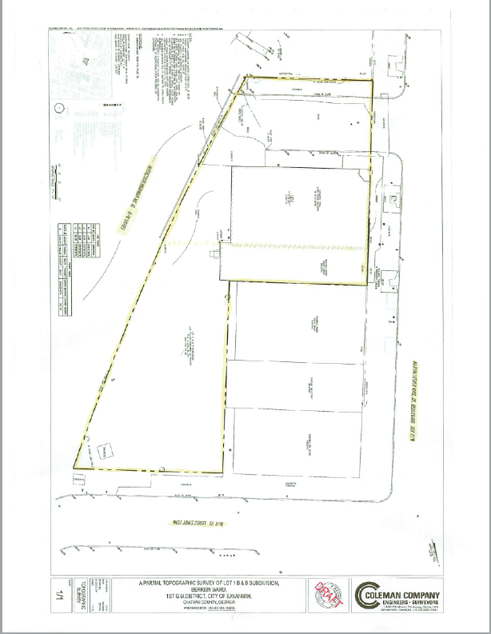

EXHIBIT B

