RESOLUTION DESIGNATING THE ST. PATRICK’S DAY
PARADE A MAJOR SPECIAL EVENT

WHEREAS, public observance of the 202nd St. Patrick’s Day Parade will occur in the City on March 17, 2026; and

WHEREAS, the St. Patrick’s Day Parade, and associated festival, requires a citywide approach for its effective and secure execution due to the significance of its scale and impact; and

WHEREAS, the Mayor and Aldermen enacted a Major Special Events Ordinance in 2024, which provides that, upon the recommendation of the City Manager, the Mayor and Aldermen are empowered to formally recognize and designate Major Special Events within the City of Savannah; and

WHEREAS, designation of a Major Special Event shall occur by resolution delineating event-specific rules and regulations; and

WHEREAS, the Mayor and Aldermen are also vested with the authority to designate by resolution control zones wherein the City Manager has comprehensive authority to implement and enforce regulations and controls necessary to ensure the safety, orderliness, and success of the St. Patrick’s Day Parade;

NOW, THEREFORE, BE IT RESOLVED, that the 2026 St. Patrick’s Day Parade is hereby designated a Major Special Event.

BE IT FURTHER RESOLVED that the area identified below shall be designated a Control Zone and that the City Manager is hereby authorized to implement and enforce regulations and controls set forth at City Code Section 3-6107.

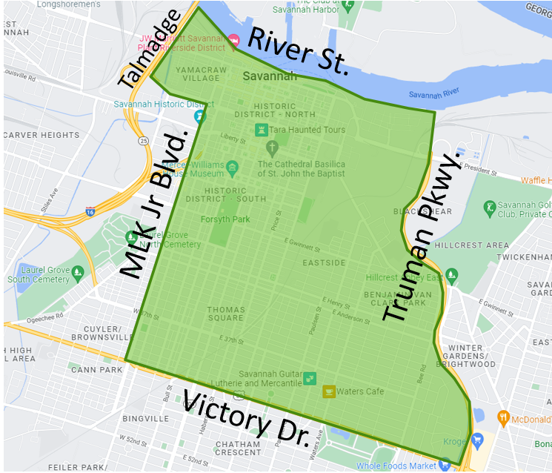

ADOPTED and APPROVED this __________ day of March, 2026.

____________________________________
Van R. Johnson II
Mayor

__________________________________
Mark Massey
Clerk of Council

