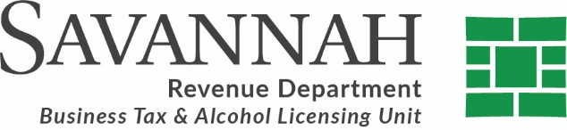

TO: Jay Melder, City Manager
FROM: Judee Jones, Revenue Manager
SUBJECT: Request for Adoption of Resolution Authorizing Sunday Alcohol Sales for Bars/Lounges on March 15, 2026
DATE: February 9, 2026
The purpose of this memorandum is to request adoption of a resolution authorizing bar and lounge establishments to sell alcoholic beverages for on-premises consumption on Sunday, March 15, 2026. If approved, this item will be placed on the City Council agenda for February 26, 2026.
In 2015, the state legislature amended the Alcoholic Beverage Control Act in response to requests from the hospitality industry. The amendment permits bars to sell alcoholic beverages on one Sunday per calendar year, provided the local governing body adopts a resolution or ordinance authorizing such sales.
The relevant statutory authority is provided in § 3-3-7(r), Local Authorization and Regulation of Sales of Alcoholic Beverages on Sunday, which states in part:
Notwithstanding other provisions of law, in all counties or municipalities in which the sale of alcoholic beverages is lawful for consumption on the premises, the governing authority of the county or municipality, as appropriate, may by adoption of a resolution or ordinance authorize the sale of alcoholic beverages for consumption on the premises from 12:30 p.m. until 12:00 midnight on one Sunday during each calendar year that shall be designated in such resolution or ordinance. Any sales for consumption on the premises made pursuant to this subsection shall be subject to such terms and conditions as may be required by the governing authority of the county or municipality.
In 2026, St. Patrick’s Day falls on Tuesday, March 17. Historically, participation in the hospitality industry is strongest when the authorized Sunday immediately precedes the holiday.
To assess interest, the Revenue Department distributed a survey and conducted follow-up phone calls to bar and lounge establishments that are typically closed on Sundays. The results indicate that approximately 84 percent of respondents support operating on Sunday, March 15, 2026.
The Revenue Department will discuss the proposed adoption of this resolution at the quarterly Alcohol Informational Session on Tuesday, March 11, 2026. A draft resolution is attached for the City Council’s consideration, which would permit bar and lounge establishments to sell alcoholic beverages for on-premises consumption on March 15, 2026, in compliance with state law.

