C H A T H A M C 0 LI N T Y S A V A N N A H

**METROPOLITAN PLANNING COMMISSION**

*“Planning the Future - Respecting the Past ”*

M E M O R A N 0 U M

**DATE:**

**June 24, 2025**

DECISION

FROM: METROPOLITAN PLANNING COMMISSION

**SUBJECT: Major Subdivision**

PETITION REFERENCED:

**Owner:** Arroyo Cap 3 2, LLC.

Agent: Steven Baker, for K. Hovnanians Address: New Hampstead PD; Tract R-6 Phase 2 Alderman **District:** 5 — Dr. Estella Shabazz **County** Commission **District:** 5 — Tanya Milton **Property Identification Number:** 21007 01003 **Petition File Number:** 25-002514-SUBP

MPC DECISION:

The Planning Commission approves the proposed Major Subdivision subject to the following conditions:

1. Show the signature of a Georgia Registered Land Surveyor and appropriate dedications of right-of way, shared community spaces, and storm water features.
2. Approval by the Chatham County Health Department and the City review departments including the City Engineer.

MPC STAFF RECOMMENDATION:

MPC Staff recommends aooroval of the proposed Major Subdivision subject to the following conditions:

* 1. Show the signature of a Georgia Registered Land Surveyor and appropriate dedications of right-of way, shared community spaces, and storm water features.
  2. Approval by the Chatham County Health Department and the City review departments including the City Engineer.

Major Subdivision

File No. 25-002514-SUBP

MPC Page 2 of 2

June 24, 2025

MEMBERS PRESENT: 12

Traci Amick Laureen Boles

Travis Coles — Vice Chair Karen Jarrett — Chairwoman Michael Kaigler

Jay Melder Jeff Notrica Stephen Plunk Coren Ross Joseph Ervin

Amanda Wilson

Dwayne Stephens

PLANNING COMMISSION VOTE: Approve Staff Recommendation. (12-0)

|  |  |  |  |  |
| --- | --- | --- | --- | --- |
| APPROVAL  Votes: 12 | DENIAL  Votes: | ABSENT | Abstain | Recused |
| Amick |  | Welch |  |  |
| Boles | Woiwode |
| Coles |  |
| Jarrett |  |
| Kaigler |  |
| Melder |  |
| Notrica |  |
| Plunk |  |
| Ross |  |
| Ervin |  |
| Wilson |  |
| Stephens |  |

Respectfully submitted,

Melanie Wilson

Executive Director and CEO MW/sh

Enclosure

cc Mark Massey, Clerk of Council

Lester B. Johnson, Assistant City Attorney Jennifer Herman, Assistant City Attorney Bridget Lidy, Department of Inspections

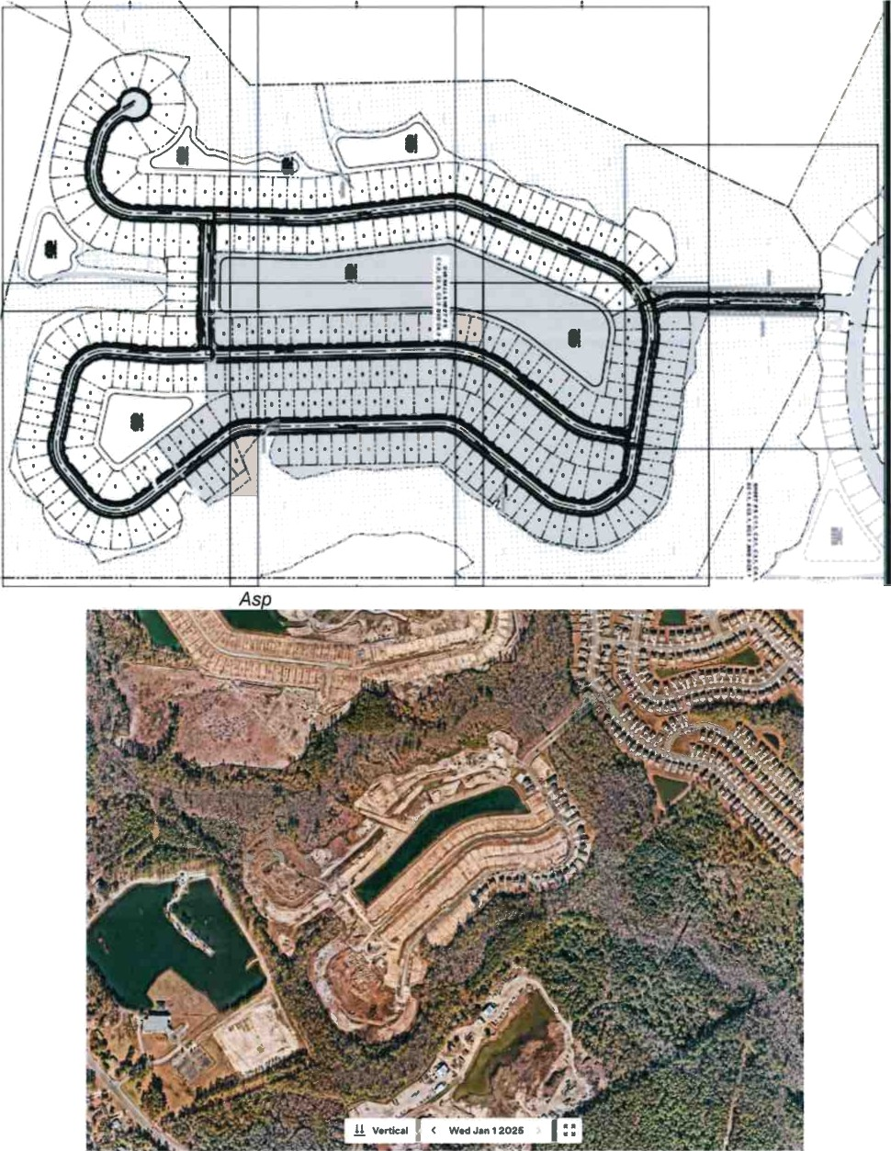*ire Subdivision Site Layout (Phase 2 in white)*

*Aspire 2025 post Site Development*

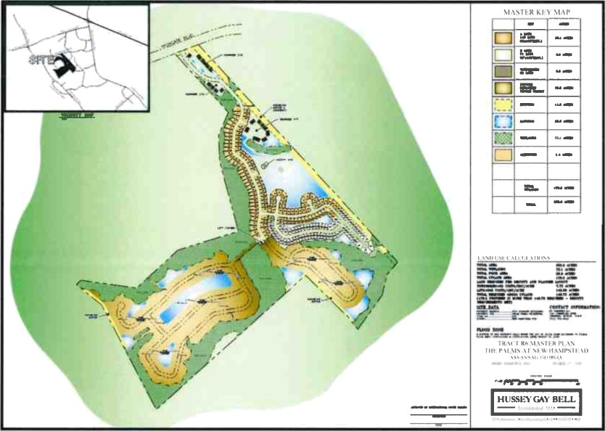

*New Hampstead Tract 6 Master Plan*

# CHATHAM COUNTY - SAVANNAH METROPOLITAN PLANNING COMMISSION DECISION

June 24, 2025

# Major Subdivision/Final Plat

New Hampstead PD; Tract R-6 Phase 2 PIN: 21007 01003

62.80 Total Acres - 134 lots

Zoning - PD (Planned Development) - New Hampstead, Tract R-6 File No. 25-002514-SUBP

Reference File Number(s): 15-006653-ZA (Text), 18-005269-ZA-MAP, 18-005271-

**ZA-TEXT, and** 23-004262-ZA

Steven Baker, Agent for K. Hovnanians Nathan Brown, Surveyor

Arroyo Cap 3 2, LLC - Owner

# Nature of Reo.uest

The Petitioner is requesting approval of a Final Plat for a 134-lot major subdivision located within the New Hampstead Tract R-6 PD (Planned Development). This proposed phase of development represents the last of two phases within the Aspire Subdivision. This subdivision also includes four common stormwater detention features and the circulator rights-of-way approved with the previous planning documents.

Findings

1. The New Hampstead Tract R-6 contains The Palms (630 D/Us) and the Aspire subdivision (266 D/Us) for a total dwelling unit count of 896 single-family and townhouse units. The proposed Aspire phase two, if approved, will result in a final

3.3 DU/AC creating 134 total lots and three new common stormwater ponds. Lot sizes vary in precise dimensions and square footage, but generally measure 52 feet by 110 feet, encompassing approximately 5,720 square feet in area. Generally, 20 foot front and rear setbacks, and 5 foot side setbacks apply. This final phase of Aspire will also dedicate approximately 4,310-feet of public right-of- way.

1. Phases comprising both The Palm and Aspire associated with Tract R-6 have a single dedicated access entrance located off Highgate Boulevard which is currently classified as a Minor Arterial Road. Highgate Boulevard has access to HWY 204/Fort Argyle Road and Little Neck Road via New Hampstead Parkway.
2. The required infrastructure improvements to support this phase of development includes the extension of water and sewer mains, the installation of water and sewer services, and the installation of a stormwater conveyance system.
3. The water and sewer service for this project area is provided and maintained by the City of Savannah.
4. The Developer will install sidewalks on the portions of all streets abutting all property other than platted single family lots in accordance with City of Savannah subdivision regulations.

**Decision:**

The Planning Commission **ageroves** of the proposed Major Subdivision subject to the following conditions:

1. Show the signature of a Georgia Registered Land Surveyor and appropriate dedications of right-of way, shared community spaces, and storm water features.
2. Approval by the Chatham County Health Department and the City review departments including the City Engineer.



Melanie Wilson, MPC Executive Director and CEO

“ / *

“ .- ““ “. ”

Ed rd Morrow, Dire@or of Development Services/Current Planning

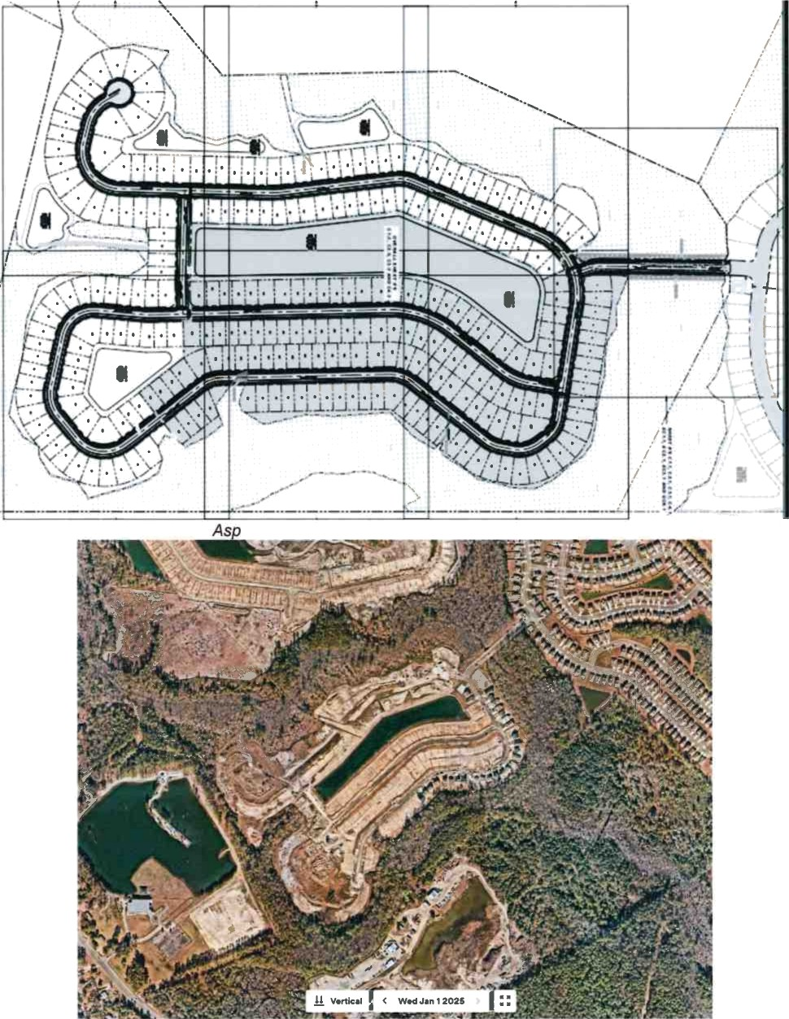*ire Subdivision Site Layout (Phase 2 in white)*

*Aspire 2025 post Site Development*

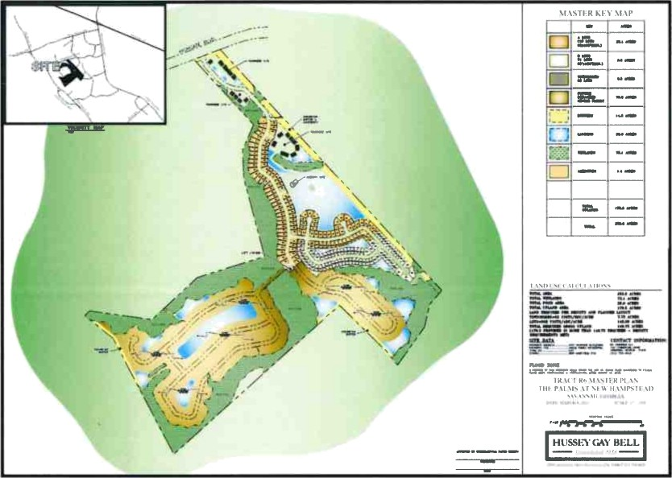

*New Hampstead Tract 6 Master Plan*