AN ORDINANCE
TO BE ENTITLED

TO AMEND THE CODE OF ORDINANCES OF THE CITY OF SAVANNAH, DIVISION II, PART 3, CHAPTER 1, SECTION 218, PARKING METER ZONES AND NON-METERED TIME-CONTROLLED ZONES; TO ESTABLISH A NEW PARKING ZONE BOUNDED BY GASTON STREET, VICTORY DRIVE, MARTIN LUTHER KING, JR. BOULEVARD, AND BROAD STREET; TO AUTHORIZE THE DEPARTMENT OF MOBILITY AND PARKING SERVICES TO ESTABLISH AND ADMINISTER METERS AND TIME ZONES WITHIN SAID AREA; TO AMEND THE REVENUE ORDINANCE, ARTICLE J, SECTION 1, TO ESTABLISH RATES FOR SAID ZONE; TO PROVIDE FOR SEVERABILITY; TO REPEAL CONFLICTING ORDINANCES; AND FOR OTHER PURPOSES.

WHEREAS, the Mayor and Aldermen of the City of Savannah are authorized under the Charter of the City of Savannah and O.C.G.A. § 36-35-3 to regulate parking and traffic upon the streets of the City in the interest of public health, safety, and welfare; and
WHEREAS, Section 218 of the Code of Ordinances authorizes the establishment of parking meter zones and non-metered time-controlled zones within the City; and
WHEREAS, the Department of Mobility and Parking Services ("DMPS") has recommended the establishment of a new parking zone within the area generally bounded by Gaston Street to the north, Victory Drive to the south, Martin Luther King, Jr. Boulevard to the west, and Broad Street to the east, in order to improve parking turnover, availability, and management within said area; and
WHEREAS, the Mayor and Aldermen desire to authorize DMPS to establish and administer specific meter locations and time-controlled zones within the boundaries described herein, and to set corresponding rates in the Revenue Ordinance;

NOW, THEREFORE, THE MAYOR AND ALDERMEN OF THE CITY OF SAVANNAH HEREBY ORDAIN:

SECTION 1.
Section 218 of the Code of Ordinances of the City of Savannah, "Parking meter zones and non-metered time-controlled zones," is hereby amended by adding a new subsection to read as follows:

Sec. 218(b). — Midtown Parking Zone.
(a) Establishment of zone. There is hereby established a parking zone, to be known as the "Midtown Parking Zone," within the area bounded as follows: on the north by Gaston Street; on the south by Victory Drive; on the west by Martin Luther King, Jr. Boulevard; and on the east by Broad Street, as more particularly shown on the official zone map on file with the Department of Mobility and Parking Services.
(b) On-street meter installation; authority to establish meters and time zones.
(1) On-street parking meters shall be installed within the following areas, located within the zone described in subsection (a):
(i) as shown in exhibit A
(ii) as shown in exhibit B
(iii)As shown in exhibit C
(iv)as shown in exhibit D
(2) In addition to the areas identified in subsection (b)(1), the Department of Mobility and Parking Services is authorized to establish, install, relocate, modify, and administer additional parking meters, pay stations, and non-metered time-controlled parking zones within the boundaries described in subsection (a), including the determination of specific block faces, hours of operation, applicable time limits, and days of enforcement, upon the recommendation of the Director of Mobility and Parking Services or the Director's designee, provided that no time-controlled parking zone established under this subsection shall permit parking for a period exceeding two (2) hours. Such determinations shall be made in accordance with the standards and procedures generally applicable to parking meter zones and time-controlled zones elsewhere in this section, and shall be evidenced by administrative order of the Director, filed with the Clerk of Council and reflected on signage and the official zone map.
(c) Rates. Rates for parking meters and time-controlled parking spaces established within the Midtown Parking Zone shall be as set forth in the Revenue Ordinance, Article J, Section 1, and be amended from time to time.

SECTION 2.
Article J, Section 1, of the Revenue Ordinance of the City of Savannah is hereby amended by adding a new provision to read as follows:
Section 1
(c)Zone 3: The Managed Parking District of the City is the area bounded on the north by Gaston, on the east by the eastern curb line of East Broad Street, on the south by the southern curb line of Victory Drive, and on the west by the western curb line of Martin Luther King Boulevard.
Zone 3: $1.50 per hour
Time-controlled parking rates within the Midtown Parking Zone, established pursuant to Section 218(b) of the Code of Ordinances, shall be $1.50 per hour (or fraction thereof) with a maximum permitted parking duration of two (2) hours per space, or such other rate or duration as may be set by resolution of the Mayor and Aldermen upon recommendation of the Department of Mobility and Parking Services, and as published on the Department's official rate schedule.

SECTION 3. SEVERABILITY.
If any section, subsection, sentence, clause, phrase, or portion of this ordinance is for any reason held invalid or unconstitutional by a court of competent jurisdiction, such portion shall be deemed a separate, distinct, and independent provision, and such holding shall not affect the validity of the remaining portions of this ordinance.

SECTION 4. REPEALER.
All ordinances and parts of ordinances in conflict herewith are hereby repealed to the extent of such conflict.

SECTION 5. EFFECTIVE DATE.
This ordinance shall become effective immediately upon adoption by the Mayor and Aldermen, or upon such later date as may be specified by the Department of Mobility and Parking Services for installation of signage and equipment.

ADOPTED this _____ day of ____________, 2026.

_______________________________
Van R. Johnson, Mayor, City of Savannah

ATTEST:

_______________________________
Mark Massey, Clerk of Council

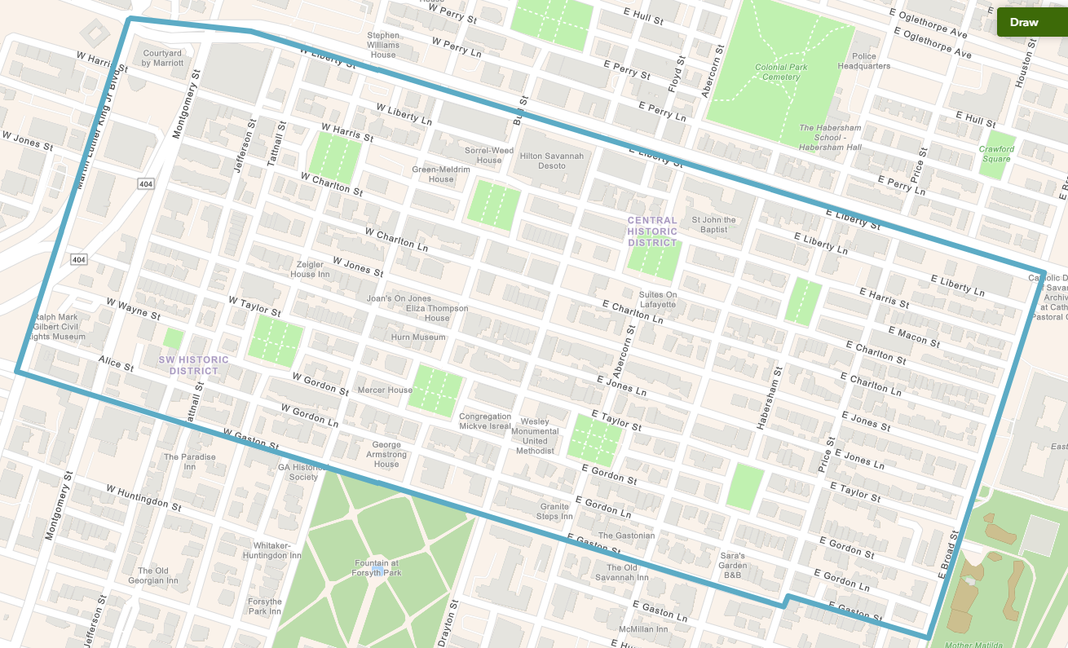
Exhibit A

Exhibit B
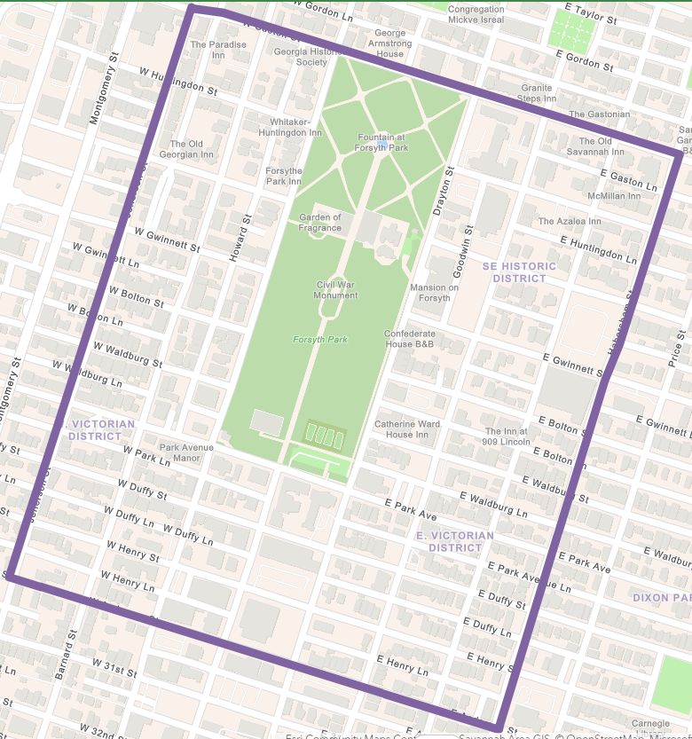

Exhibit C
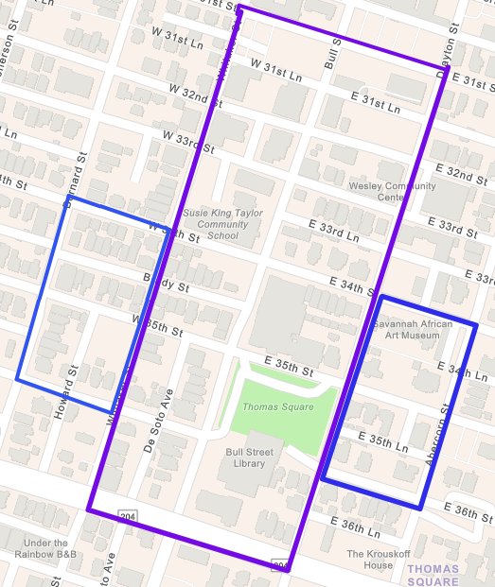

Exhibit D
