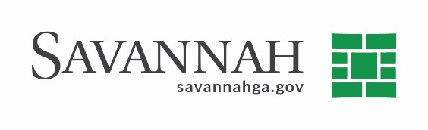

Purchasing Notes
Event # 11095 | Title: Georgetown water reclamation facility | Cost: 5,315,500
Type of Procurement: RFP | Annual Contract ☐  Annual Maintenance Agreement ☐ | One-Time Purchase ☒
Contract Term (If Applicable)

S/DBE (If Applicable)
This event had a 20% DBE goal, which 10% had to be met by a local DBE.
Matrix (If Applicable)
N/A
Notes
See the agenda description for details regarding this item

