- Attached
- Water Works Site Pedestrian Walkway Continuation - Mural 2 and 3
- No D.

Description
Nearly 130 years ago, the Savannah Water Works Pump Station began treating the city’s water supply at the Water Works Pump House in West Savannah at Gwinnett Street and Stiles Avenue. The 19th-century brick industrial warehouse building still strikes a commanding presence on its Westside Savannah lot with its expressive arches and towering stack. In light of the neighboring Canal District development, which began in 2020, attention turned toward breathing new life into the Water Works Site while maintaining its historic character and architectural relevance. The City of Savannah has expressed a clear desire to preserve historic structures and enhance the lot for environmental, social, and economic benefits.

The Water Works Pedestrian Walkway will be a mural painted directly onto the asphalt of the Water Works Site, which is adjacent to the Arena and developing Canal District Trail. This commissioned artwork of five artist teams will be the largest asphalt mural in Chatham County, with each of the five murals at 120ft x 20ft or approx 2,400 sq ft.

With the completion of the first approved section of the mural by the McGregor group in February of 2022, the continued work of the following two murals will occur throughout the spring of 2022. The Adolfo and Hebermehl group will continue to fuse their designs into the Pedestrian Walkway, installing designs based on the natural environment of the community and the people who have lived throughout it.

The Adolfo Group will seamlessly connect with the first mural \ by also incorporating designs of the surrounding natural environment by utilizing the visual approach of the Savannah River. The design also portrays raindrops that create ripples in the river that will then morph into different-sized oak tree rings, expressing the many connections of life in general. “We envision children, even adults, having fun through the pathway jumping from ripple to ripple, imagining that they themselves create ripples as they land on each point.”
Following completion of the Adolfo group’s installation, the Hebernehl group will continue the path with designs based on the people of the area. It will encompass the spirit of those from its past, present and future. It will consist of flowing gestural lines or “paths” that connect figures and flora into one body, threading a thoroughfare to our collective past, present and future.”. Visitors and art enthusiasts alike will share the

experience of seeing themselves in the works and marveling in the colorways, the formal aspects of the art itself and the flowing shapes and interconnected lines. This work is designed to create an endless number of paths within the pathway.

Materials
- Behr Premium Tinted concrete paint with primer
- Behr White concrete base paint and Paint tint
- High quality exterior Modern Masters acrylic theme paint
- Exterior Water Based House Paint over top of Exterior Primer
- H&C SHIELD-CRETE Acrylic Clear Glaze Coat
- H&C COLORTOP Water-Based Solid Color Concrete Stain

H - Theme:
Given its importance to the site and the neighboring communities, the artwork supports the theme of Savannah’s Pathways. The theme allowed artists to elaborate on their interpretations of pathways including roads, nature trails, and man-made paths, but also the natural and/or man-made structures that line those physical pathways and the people who have created and walked them. Artists were also allowed and encouraged to utilize familiar landmarks and flora or fauna native to the Savannah area. The Adolfo Group will also incorporate the natural environment of the surrounding area by starting with the approach of the Savannah River morphing rain droplets into oak tree rings.
Hebernehl group will focus on the people of Savannah’s paths and will “consist of flowing gestural lines or "paths” that connect figures and flora into one body thus threading a thoroughfare to our collective past, present and future. Visitors and art enthusiasts alike will share the experience of seeing themselves in the works and marveling in the colorways, the formal aspects of the art itself and the flowing shapes and interconnected lines.

I - J. The Pedestrian Walkway is a part of the larger Water Works Placemaking Project, which borders the new Enmarket Arena and the developing Canal District Trail. The Water Works Site is now largely inaccessible for public use and sits adjacent to the new City of Savannah Enmarket Arena & Canal District, which began development in 2020. The entire project, including the mural pathway, is a multi-pronged site project that aims to improve mobility, safety, and health of the neighboring community and support the economic growth of an area neglected for several decades. Local artists and community members will become key stakeholders in the design and creation of this walkway which will ensure a sense of ownership and stewardship for the site.

K. The artist team selection was made through an RFP call-out process from the City of Savannah and selected by a group of community members and public art enthusiasts within Savannah. See attached RFP information packet.

I. See Attached Document

- Timeframe for Mural 2 will be, upon approval, throughout April 2022, with Mural 3 taking place following the completion of Enmarket Arena parking garage slated for May 2022.

- During the RFP submission period, an online Webinar was held for the public to answer any questions and expand on the concepts of both the mural pathway and the entire Water Works site activation. The Arena Community Task Force is composed of several presidents and active members of many West Side Neighborhood Associations as well as Alderman Lanier. This groupwas presented with the mural project concepts and chose the theme of the mural itself, “Savannah’s Pathways”. In December of 2021, both Adolfo and Hebermehl Group met with the Community Task Force representatives and reviewed their designs with the group - feedback was heard and ultimately approval for the installations was provided. Those not in attendance for the meetings were sent emails with meeting notes and decisions.

- Not applicable

- TBD

CHECKLIST:

  - Provide a completed application form.
  - Provide the title for the mural.
  - Is the mural with the Savannah Local Historic District (see attached map)? If yes, provide a copy of the approved Certificate of Appropriateness from the Historic District Board of Review.
  - Provide a written description of the proposed mural. At a minimum, include materials and dimensions.
  - Provide color photographs of the proposed location for the mural (site conditions from all sides).
  - Provide a map for the location of the mural.
  - Provide color renderings or drawings of the proposed mural.

  - Provide a statement describing the theme of the mural. Explain how the theme is respectful to the greater
context of the community, including historic and socio-cultural contexts.
  - Provide a statement indicating how the scale and design of the mural are appropriate to, complements, and enhances the building or structure.
  - Provide a statement describing how the mural enhances and complements the context and character of the surrounding neighborhood.
  - Provide a description of the Artist Selection Process utilized.
Questions: Email the Preservation Department at historic@thempc.org or call 912-651-1440.
7 Revised 12/2017
  - Provide a list and images of recent works of art of similar size and scale in the public arena completed by the
designer/artist.
  - Provide an estimated timeframe for installation of the mural.
  - Provide a statement describing any neighborhood outreach, meetings, or feedback received.
  - If the mural is intended to be temporary, provide a removal plan.
  - Provide a determination from the Zoning Administrator that the proposal is a mural and not a sign.

HISTORIC SITE AND MONUMENT COMMISSION (HSMC)
Application for Historical Markers, Monuments, and Public Art
HSMC reviews all historical markers, monuments, and public art on public property; markers, monuments, and public art visible from the public right-of-way on private property within all local historic districts; murals visible from the public right-of-way. Applications must be complete before the HSMC can begin the review process. Submit this application form and all supplemental documentation as required in the “Instructions: Submittal Criteria Checklist” with one hard copy and in PDF electronic format. Email submissions to historic@thempc.org. Ensure the file size does not exceed 15 MB. If Email is not available, contact the office for alternate arrangements.

File No.: (staff only)
Applicant Contact Information:
Name: Erin Wessling Address: 12 W. State Street Fl. 2 City: Savannah State Georgia Zip 31401 Phone: 303.249.9583 E-Mail Address erin@wprojects.co
Property Owner Contact Information and Consent (Complete only if the marker will be on private property):
Name: Bret Bell Address: 1100 W. Gwinnett Street City: Savannah State Georgia Zip 31415 Phone: 9126671825 E-Mail Address bbell@savannahga.gov
Official Correspondence: Applicant Owner Other (Check all that apply)
❑
❑
❑
Property Information: (PIN information can be found at www.sagis.org.)
Public Property Private Property PIN (Property Identification Number): 20046 02001
❑
❑
Address: 1204 W GWINNETT STREET, SAVANNAH GA 31415
Scope of Work: (Check all that apply.)
❑
❑
❑
❑
❑
❑
❑
❑

HISTORICAL MARKER: | MONUMENT:
Freestanding | Person
Wall-Mounted | Place
Ground-Embedded | Event
Other: | Other:
PUBLIC ART / MURAL (Commissioned or Existing Work): | NAMING AND RENAMING:
Mural | Public Property
Sculpture | Public Facilities
Other: | Public Streets

Project Description: Describe the proposed project and scope of work in detail. Additional pages may be attached. Submit all supplemental documentation as required in the separate “Instructions: Submittal Criteria Checklist.”
❑
❑
❑
❑
❑
❑
See Attached document for description and checklist

Questions: Email the Preservation Department at historic@thempc.org or call 912-651-1440.
1

Revised 12/2021

2022 Savannah-Chatham County Historic Site and Monument Commission Meeting Schedule:

Application Deadline (Due by Close of Business: 5pm) | Meeting Date
□ Thursday, December 2, 2021 | Thursday, January 6, 2022
□ January 6 | February 3
□ February 3 | March 3
� March 3 | April7
□ April 7 | May5
□ May5 | June 2
□ June 2 | July 7
□ July 7 | August 4
□ August 4 | September 1
□ September 1 | October 6
□ October 6 | November 3
□ November 3 | December 1

Estimated Cost of the Proposed Work: $_$_3_8--',0_0_0_._0_0 _

Filing Fee Schedule:
No filing fee is required for HSMC review.

Public Notice for Historic Site and Monument Commission Meetings:
The applicant is responsible for posting the Board Meeting signs provided by the MPC fifteen (15) days prior to the HSMC Meeting. Refer to Chapter 9 of the Markers, Monuments, and Public Art Master Plan and Guidelines for the City of Savannah for additional posting requirements.

Signature of Legal Owner or Authorized Agent:
I have read and understand all the information enclosed in this application form. I understand that an Escrow Payment is required for an historical marker erected on ublic property. I hereby certify that I am the legal owner or authorized agent for owner of

Questions: Email the Preservation Department at historic@thempc.org or call 912-651-1440.
2 Revised 12/2021

Mural 2 and 3 Review
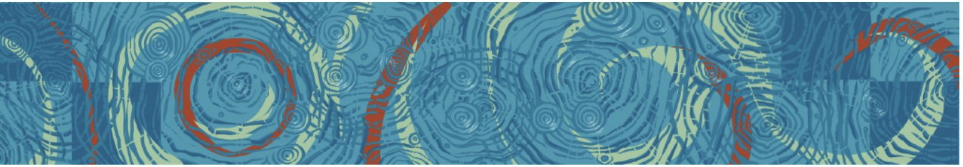
MURAL 2 ARTISTS: Adolfo H ALvarado

About 12,000 years ago, Paleoindians rst appeared along the Savannah River near the end of the Ice Age. Sometime during the early 17th century, the Westo Indians took up residence along the river. The Westo used the river for fishing and water supplies, transportation, and trade. The name "Savannah" comes from the Shawnee and many historians believe the word was borrowed from the Taino word zabana.

The Savannah River swiftly flows down the southeastern side of the Appalachian Mountains making its way into gentle slopes and starts to meander across forestry regions merging into the Atlantic ocean. Our Concept design portrays raindrops creating ripples in the river. Ripples also morph into different-sized oak tree rings. Forming many connections of life in general. We envision children, even adults, having fun through the pathway jumping from ripple to ripple. Imagining that they themselves create ripples as they land on each point.

Adolfo H Alvarado
in collaboration with SeeSAW Approx. Size: my section 10ft x 45ft Savannah, GA
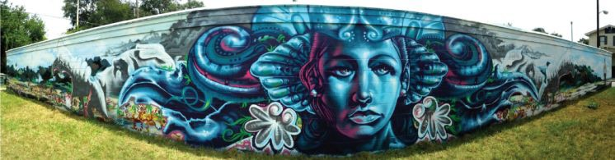
2012

Group Experience

8’x60’

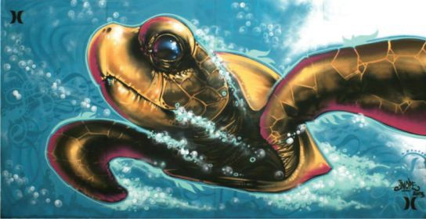
Hurley Wall at Ron Jon Festival - Adolfo H Alvarado
Approx. Size: 8ft x 16ft Coco Beach, FL

MURAL 3: Hebermehl Group
ARTISTS: Matthew Hebermehl, katherine sandoz, Jamie Bourgeois, Troy Wandzel

We propose an artwork that consists of flowing gestural lines or "paths” that connect figures and flora into one body, threading a thorough fare to our collective past, present and future. Visitors and art enthusiasts alike will share the experience of seeing themselves in the works as well as marveling in the color ways, the formal aspects of the art itself and the flowing shapes and interconnected lines. This work is designed to create an endless number of paths within the pathway.

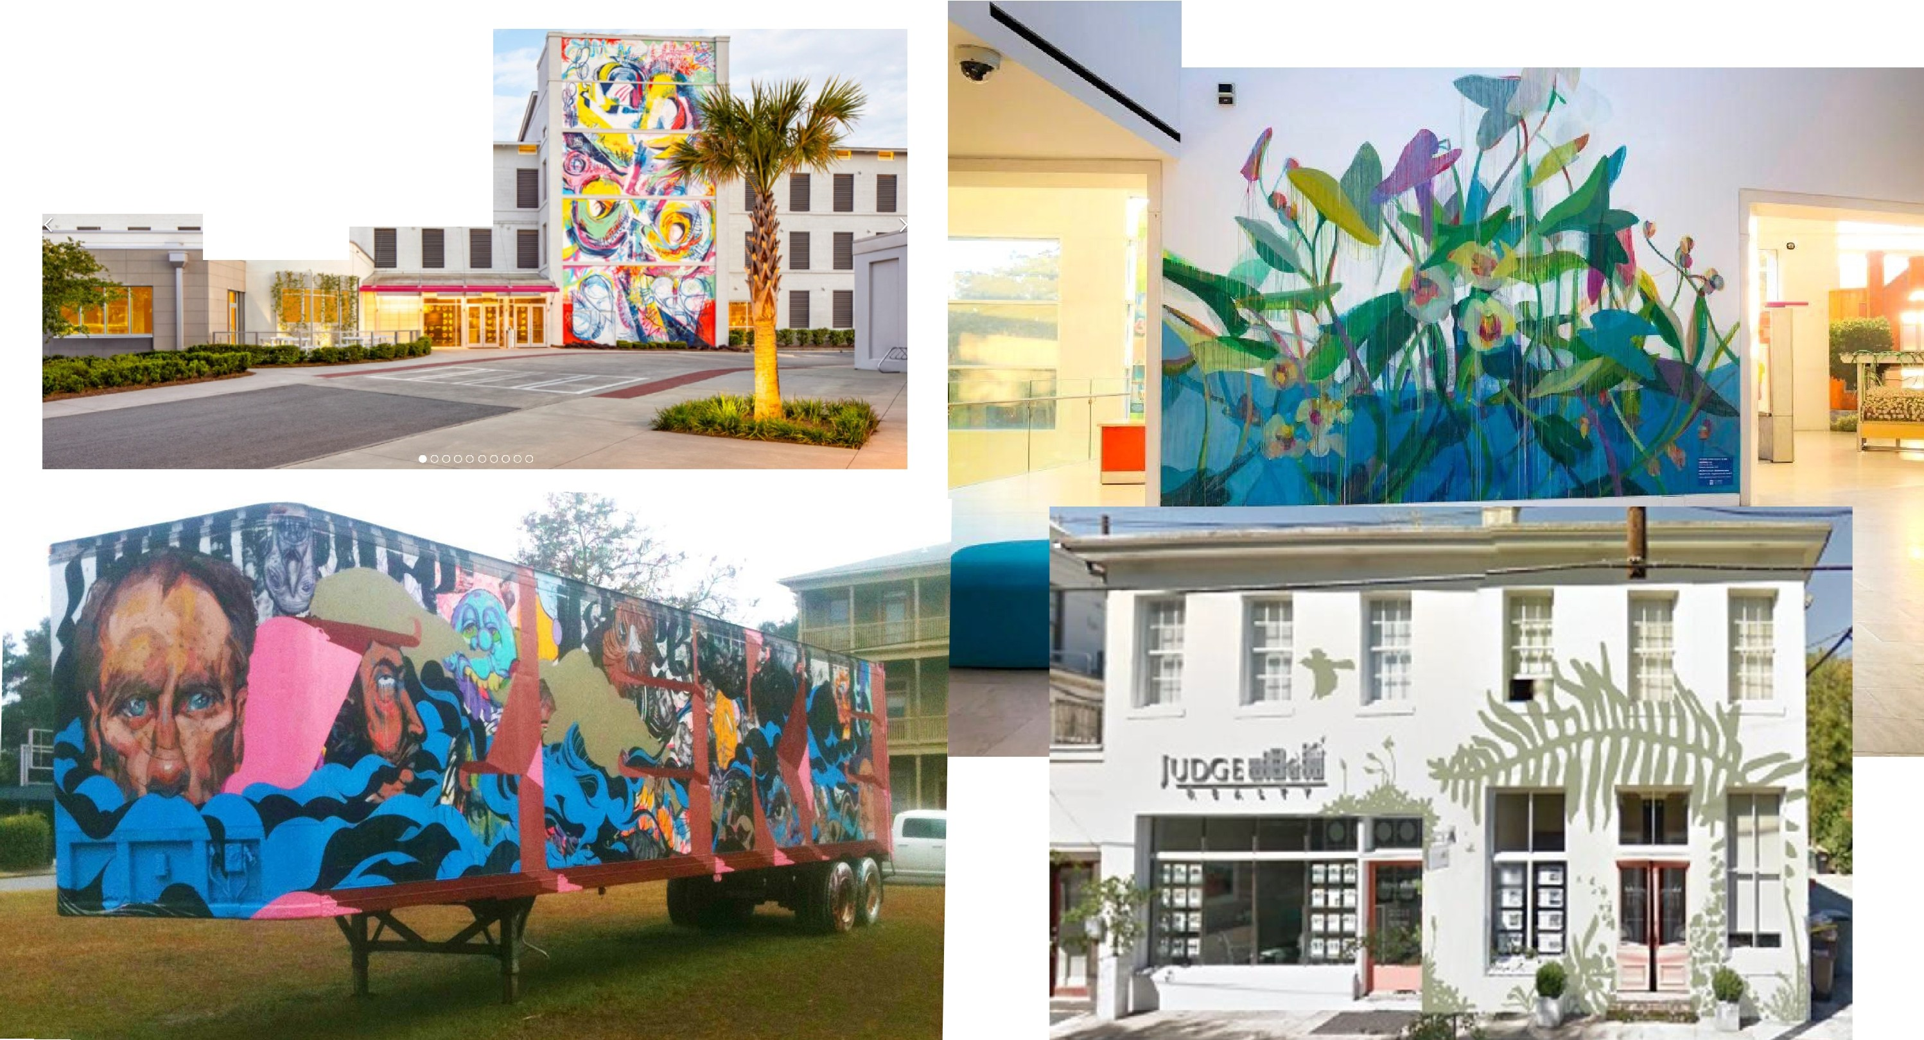

111111�1-1­11
-
liill---. ,.-

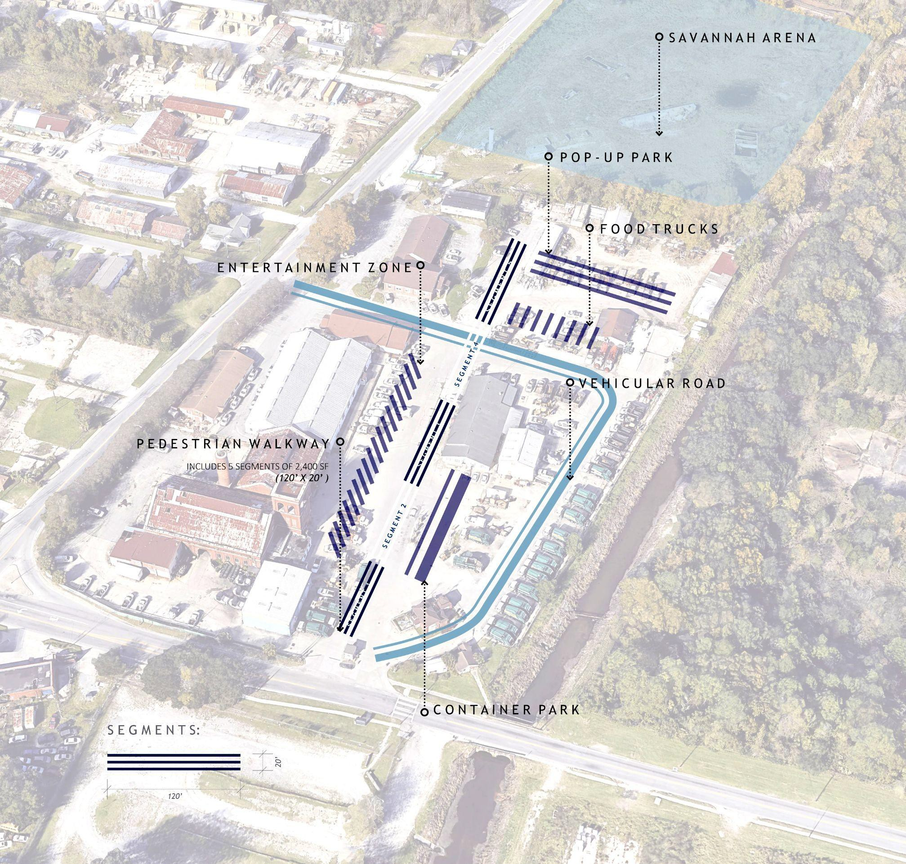

Pedestrian Pathway Layout
- Entrance: Arena South end

- Size: 650’ L X 20’ W

- Sections: 5

- Professional installation: 4

- Student installation: 1

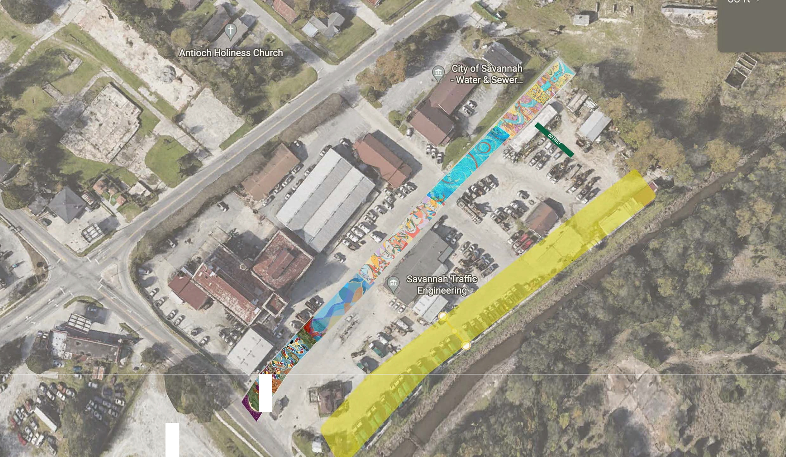

I
/.

•

