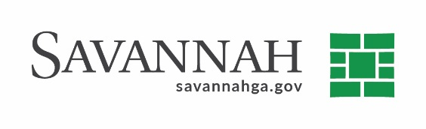
Purchasing Summary
Event #6648 | Title: External Audit Services | Cost: $123,738.00
Type of Procurement: RFP | Annual Contract ☒  Annual Maintenance Agreement ☐ | One Time Purchase ☐
Contract Term (If Applicable)
January 1, 2021 through December 31, 2021

DBE (If Applicable)
N/A
Matrix (If Applicable)

Notes
Recommend approval to renew an annual contract for External Auditing Services with Mauldin & Jenkins^{(B)} in the amount of $123,738. The contract renewal will be applicable to the financial statements dated December 31, 2020.
The City is required by state and federal regulations to undergo an annual external audit to determine whether or not the published financial statements are prepared in accordance with applicable standards.
An RFP was published in 2018 and received one proposal. The original contract was approved by Council on December 6, 2018. This is the second of four annual renewal options available. The contract term shall be January 1, 2021 through December 31, 2021.

Mauldin & Jenkins^{(B} (Savannah, GA) $123,738

(B) Indicates local, non-DBE business. Recommend approval.

