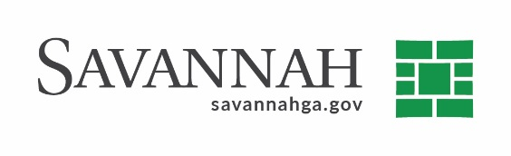
Purchasing Summary
Event #7838 | Title: Maintenance for Microsoft Software | Cost: $635,033.69
Type of Procurement: Cooperative purchase | Annual Contract ☐  Annual Maintenance Agreement ☒ | One Time Purchase ☐
Contract Term (If Applicable)
This contract will expire on June 30, 2021
DBE (If Applicable)
N/A
Matrix (If Applicable)
N/A
Notes
Recommend approval to procure maintenance for Microsoft enterprise software from Insight Public Sector, Inc. in the amount of $635,033.69. The Department of Information Technology will use this agreement to support the usage of Microsoft products by all city departments. This service will allow all City employees to utilize Microsoft 365, Microsoft Teams, Microsoft Office and other platforms.
This procurement was made through a cooperative purchasing agreement with Omni-U.S. Communities - #4400006644. Cooperative purchasing is authorized as an appropriate procurement method in Division 10 Section 4-4152 of the City of Savannah’s purchasing ordinance. The contract was competitively bid by Omni and awarded to Insight Public Sector, Inc. The contract expires on April 30, 2021 and has three renewal options available.

S.C. Insight Public Sector, Inc. (Tempe, AZ)^{(D)} $635,033.69

A pre-proposal meeting was not conducted as these services are being procured through the use of a cooperative purchasing agreement. (D) Indicates non-local, non-DBE business. Recommend approval.

Local available: No
Total sent: 1
Total received: 1

