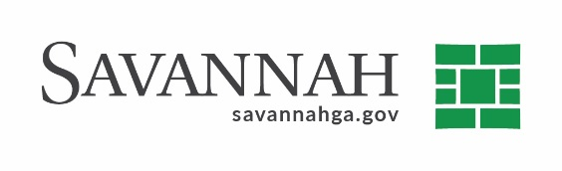
Purchasing Notes
Event #8391 | Title: Sandblasting 3 Clarifiers | Cost: $786,639.00
Type of Procurement: Bid | Annual Contract ☒  Annual Maintenance Agreement ☐ | One Time Purchase ☒
Contract Term (If Applicable)
N/A
S/DBE (If Applicable)
This event had a 20% DBE,10% LDBE goal. The recommended proposer submitted LDBE participation at the subcontractor level in the amount of 20% using E & D Contracting Services, Inc.^{(A)}
Matrix (If Applicable)
N/A
Notes
The bid was advertised, opened, and reviewed. Delivery: As needed. Terms: Net 30 days. The bidders were:

L.B. E & D Coatings, Inc. (Savannah, GA) ^{(B)} $786,639.00

A pre-bid conference was conducted (B) Indicates Local, Non-DBE owned business. Recommend approval.

