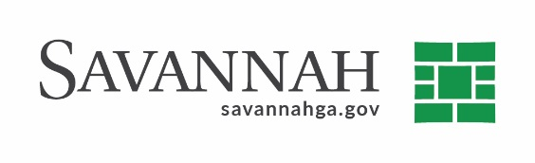
Purchasing Notes
Event #6100 | Title: Contract Modification for One-Ton Chlorine Cylinders | Cost: $18,180
Type of Procurement Contract Modification | Annual Contract ☒  Annual Maintenance Agreement ☐ | One Time Purchase ☐
Contract Term (If Applicable)
February 24,2022
S/DBE (If Applicable)

Matrix (If Applicable)
N/A
Notes
Recommend approval of a contract modification for One-Ton Chlorine Cylinders from JCI Jones Chemicals (1433 Talleyrand Ave, Jacksonville, FL) in the amount of $18,180.

This modification is due to the increase in cost of raw material. The price of the one-ton chlorine cylinders is from $490.00/ton to $660.00/ton.

Delivery: As needed. Terms: Net 30 days. The vendor is:

This contract was originally renewed by Council on February 25,2021 in the amount of $112,500. The contract amount to date including this modification is $130,680. Delivery: As needed. Terms: Net 30 days.

JCI Jones Chemical Inc. (1433 Talleyrand Ave, Jacksonville, FL) (D) $18,180.

(D) Indicates non-local, non-DBE business. Recommend approval.

