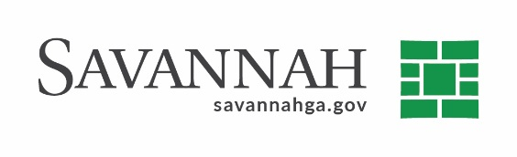
Purchasing Notes
Event #8453 | Title: Dredging of Alum Sludge Pond at I & D Plant | Cost: $131,250.00
Type of Procurement Bid | Annual Contract ☒  Annual Maintenance Agreement ☐ | One Time Purchase ☒
Contract Term (If Applicable)
N/A

DBE (If Applicable)
N/A

Matrix (If Applicable)
N/A
Notes
The bid was advertised, opened, and reviewed. Delivery: As needed. Terms: Net 30 days. The bidders were:

L.B. C & M Dredging, Inc. (Leesburg, FL) ^{(D)} $131,250.00

A pre-bid conference was conducted (D) Indicates non-local, non-DBE owned business. Recommend approval.

