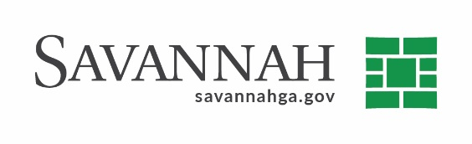
Purchasing Notes
Event #8558 | Title: Eco-Sorb | Cost: $70,000
Type of Procurement Sole Source | Annual Contract ☒  Annual Maintenance Agreement ☐ | One Time Purchase ☐
Contract Term (If Applicable)
January 2022

DBE (If Applicable)
N/A

Matrix (If Applicable)
N/A
Notes
Recommend approval of a sole source purchase for Eco-Sorb Odor Eliminator in the amount of $70,000.

This is a Sole Source purchase because OMI Industries is the manufactured supplier for the specialized equipment and proprietary chemical.

S.S. Ovivo (Townsend, GA) ^{(D)}$70,000

