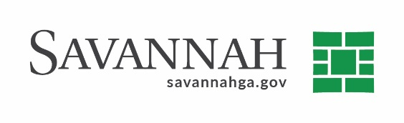
Purchasing Notes
Event #8526 | Title: Ovivo Belt Press Parts | Cost: $42,079.12
Type of Procurement Sole Source | Annual Contract ☒  Annual Maintenance Agreement ☐ | One Time Purchase ☒
Contract Term (If Applicable)
N/A

DBE (If Applicable)
N/A

Matrix (If Applicable)
N/A
Notes
Recommend approval of a sole source contract for Ovivo Belt Press part in the amount of $42,079.12.

This is a Sole Source contract because Ovivo is the manufacturer of the parts.

S.S. Ovivo (Round Rock, TX) ^{(D)}$42,079.12

