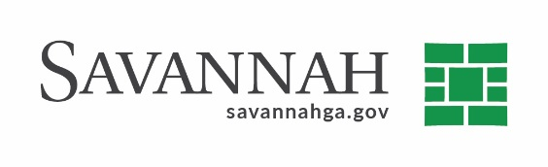
Purchasing Summary
Event #7696 | Title: Roll-Off Containers | Cost: Up to $45,785
Type of Procurement: Bid | Annual Contract ☒  Annual Maintenance Agreement ☐ | One Time Purchase ☐
Contract Term (If Applicable)
Contract term expires on December 31, 2021

S/DBE (If Applicable)
This project was not identified as an SBE project because the requirement of three certified SBEs could not be met at the time that this event was released.

Matrix (If Applicable)
N/A
Notes
Recommend approval to renew an annual contract for the purchase of commercial-type roll-off containers with Lewis Steel Works^{(D)} in the amount of $45,785. The Sanitation Department uses the roll-off containers to replace worn or damaged units from inventory. Containers will be placed at various locations throughout the City to be used by contractors and citizens for waste disposal.
This original contract was bid and approved by Council on May 14, 2020. This is the first of four annual renewal options available.
Lewis Steel Works^{(D)} (Wirens, GA) $45,785
(D) Indicates non-local, non-DBE business

