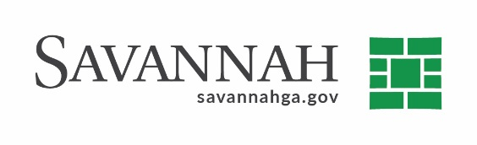
Purchasing Summary
Event #8152 | Title: Recorder’s Court Probation Services | Cost: Cost Neutral
Type of Procurement: Piggybacking purchase | Annual Contract ☒  Annual Maintenance Agreement ☐ | One Time Purchase ☐
Contract Term (If Applicable)
August 20, 2021
DBE (If Applicable)
N/A
Matrix (If Applicable)
N/A
Notes
Recommend approval to execute an annual contract for Recorder’s Court probation services with Southeast Corrections, LLC with no cost to the City. The fees for the services are paid by the clients of the contractor as specified in the contract.
Southeast Corrections has been satisfactorily providing probation services for the City of Savannah and Recorders Court of Chatham County since 2013.
Per Section 2-4154 of the City’s purchasing ordinance, the City may purchase goods or services using a competitively bid contract from other governmental agencies. (Piggybacking) The contract used for this procurement is a Chatham County contract for Probation Services. It was competitively bid by Chatham County and awarded to Southeast Corrections, LLC. The contract will expire on August 20, 2021 with four annual renewal options.
P.B. Southeast Corrections, LLC (Duluth, GA)^{D} Cost Neutral
(D) Indicates non-local, non-DBE business.

