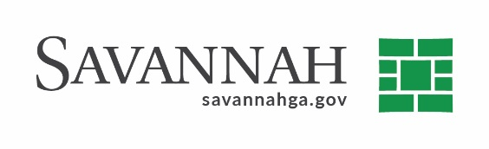
Purchasing Summary
Event #7371 | Title: Mohawk Park Project | Cost: $198,315.06
Type of Procurement: Sole Source | Annual Contract ☐  Annual Maintenance Agreement ☐ | One Time Purchase ☒
Contract Term (If Applicable)
N/A
S/DBE (If Applicable)
This event has a 20% LDBE goal established. The recommended proposer submitted DBE participation at the prime level in the amount of 10% and subcontractor level in the amount of 11% using E&D Contracting.
Matrix (If Applicable)
N/A
Notes
Recommend approval of a Final Project Closeout Amendment in the amount of $198,315.06 to Johnson Laux Construction Company for additional work performed as part of the Mohawk Park Development Project at 1132 Mohawk St.
The original contract for this project included the construction of a walking trail, playground, dog park, pavilion and a gravel parking area at the east side of the park to serve the new playground and pavilion.
The amendment is required due to additional scope of services which included additional tree removal and landscaping, necessary field changes to the water system to accommodate the east parking lot, and the addition of a second gravel parking lot to improve the existing unpaved parking lot.
The original contract was approved by City Council on September 12, 2019 in the amount of $1,027,862.12. The total contract amount to date including this change order is $1,226,177.18.
S.S. Johnson-Laux Construction (Savannah, GA)^{(A)} $198,315.06
(A) Indicates local, DBE owned business

