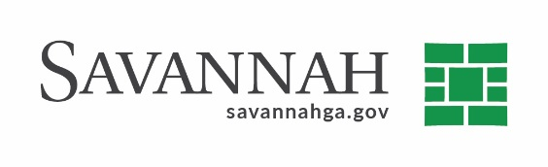
Purchasing Summary
Event #6350 | Title: Landfill Cover Material | Cost: $175,000
Type of Procurement: Bid | Annual Contract ☒  Annual Maintenance Agreement ☐ | One Time Purchase ☐
Contract Term (If Applicable)
Contract term expires on December 31, 2021

S/DBE (If Applicable)
The event had an DBE goal of 18%. The recommended bidder, SABE, Inc. submitted participation at the prime level in the amount of 100%.

Matrix (If Applicable)

Notes
Recommend approval of an annual contract renewal for landfill cover material with SABE, INC.^{(A)} for up to $175,000. The Sanitation Department uses the contract to provide cover material for usage primarily at Dean Forest Road Landfill. Cover material is applied over the waste received at the landfill on a daily basis in accordance with Georgia Environmental Protection Division rules.
The original contract was bid and approved by Council on September 27, 2018. This is the second of three annual renewal options available.
SABE, INC.^{(A)} (Savannah , GA) $175,000
(A) Indicates local, DBE business

