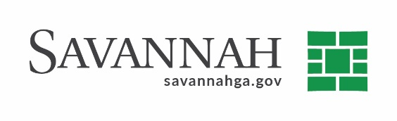
Purchasing Summary
Event #7287 | Title: Holly Heights Park Development | Cost: $15,048.15
Type of Procurement: Sole Source | Annual Contract ☐  Annual Maintenance Agreement ☐ | One Time Purchase ☒
Contract Term (If Applicable)
N/A
S/DBE (If Applicable)
The Office of Business Opportunity coordinated with the State Contractor, Johnson-Laux Construction and established a 20% DBE goal with 10% being from local DBE firms. Johnson-Laux Construction has been deemed compliant with this goal.
Matrix (If Applicable)
N/A
Notes
Recommend approval of a Final Project Closeout Amendment in the amount of $15,048.15 to Johnson Laux Construction Company for additional work performed as part of the Holly Heights Park development.
The original contract for this project included the construction of a new full-sized basketball court, stormwater infrastructure upgrades, playground and landscaping.
The amendment is required due to additional scope of services which included additional grading, installation of 12-foot fencing around perimeter of basketball court and additional stormwater upgrades necessary to complete the project.
The original contract was approved by City Council on August 1, 2019 in the amount of $347,355.29. The total contract amount to date including this modification is $362,403.43.
S.S. Johnson-Laux Construction (Savannah, GA)^{(A)} $15,048.15
A) Indicates local, DBE business

