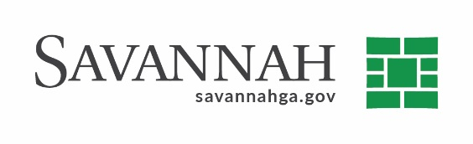
Purchasing Summary
Event #8269 | Title: Malwarebytes Maintenance Renewal | Cost: $25,000
Type of Procurement: Sole Source | Annual Contract ☐  Annual Maintenance Agreement ☐ | One Time Purchase ☐
Contract Term (If Applicable)
Contract term expires on January 13, 2022
S/DBE (If Applicable)
N/A
Matrix (If Applicable)
N/A
Notes
Recommend approval to renew an annual maintenance agreement for Malwarebytes endpoint protection software with Malwarebytes, Inc. in the amount of $25,000. The Information Technology Department uses endpoint protection to guard against malware attacks on the City’s network and defend it against numerous types of threats. This system uses a layered approach of static and dynamic detection technologies to address every stage of a malware attack.
These security measures protect the City from malicious malware, adware and spyware that could prevent City operations if an event were to occur. This is necessary for Microsoft Windows to maintain safety and security and allows PCs to run efficiently.
This is a sole source procurement because Malwarebytes is the original provider of this software and is the only vendor that can perform maintenance and service its products.
S.S. Malwarebytes, Inc. (Santa Clara, CA)^{(D)} $25,000
(D) Indicates non-local, non-DBE business.

