Recommended Prohibition of Commercial Vehicles on
Ford Avenue and Dodge Avenue

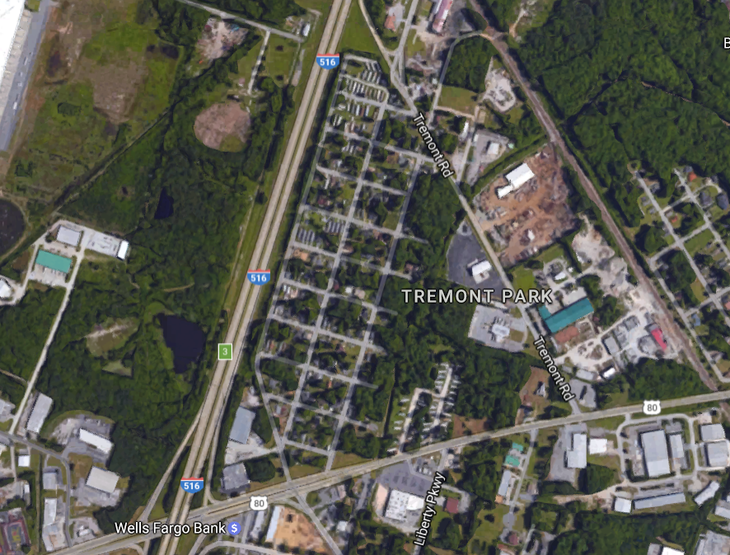
Ford Avenue
Dodge Avenue

