**Existing Bacon Park Maintenance Building**

**9/26/18**

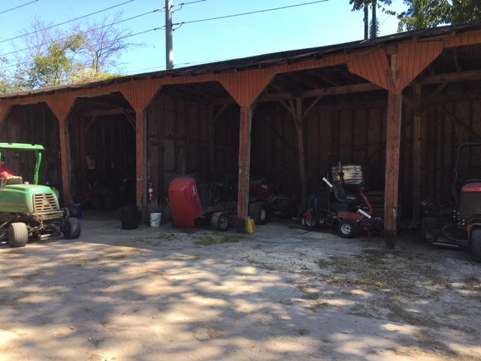

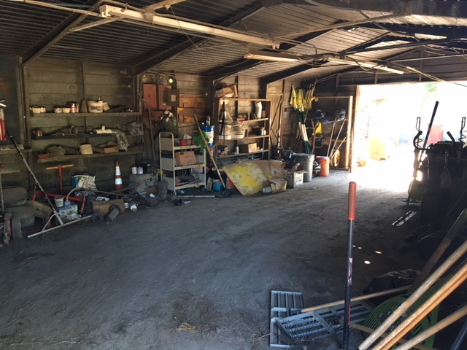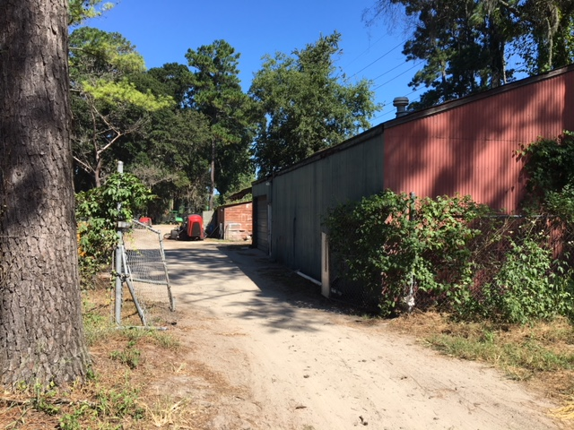

Interior of Building

West Side of Building – Facing Golf Course

East Side of Building – Facing Truman Parkway