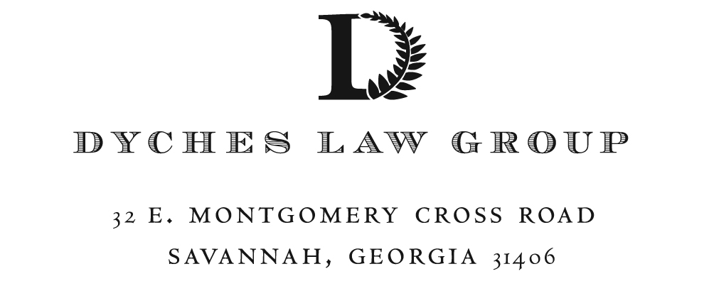
___________________________________________________________________________________________
20-01638
STATE OF GEORGIA )
) A C C E S S E A S E M E N T A G R E E M E N T
COUNTY OF CHATHAM )

This Access Easement Agreement (this "Agreement") is made this _______ day of _____________, 2022, by and between THE MAYOR AND ALDERMEN OF THE CITY OF SAVANNAH, a municipal corporation organized and existing under the laws of the State of Georgia, as Grantor (“the City”) and JOSEPH FRANKLIN MONROE, as Grantee (hereinafter, “Monroe”) (Grantor and Grantee, and their respective successors and assigns with respect to their respective rights and obligations under this Agreement are hereinafter sometimes referred to individually as a “Party,” and collectively as the “Parties”)

W I T N E S S E T H

WHEREAS the City is the owner of that certain tract or parcel of land located in Chatham County, Georgia, commonly known as the Savannah and Ogeechee Canal, being more particularly described in Exhibit "A" attached hereto and by this reference made a part hereof (the “Canal Property”); and

WHEREAS Monroe is the owner of that certain tract or parcel of land adjacent to the Canal Property, being more particularly described in Exhibit "B" and by this reference made a part hereof (the "Monroe Property"); and

WHEREAS there currently exists a driveway which runs through a portion of the Canal Property from Little Neck Road to the Monroe Property as shown and depicted on a plat of said driveway attached hereto as Exhibit "C" and by this reference made a part hereof, which driveway serves as the sole access to and from the Monroe Property and Little Neck Road; and

WHEREAS Monroe has requested that the City grant him a written agreement to create and establish the easements described below to facilitate and memorialize the same, and the City has agreed to said request.

NOW THEREFORE, the parties, in consideration of the premises and the mutual covenants contain herein, and in consideration of the sum of ONE ($1.00) DOLLAR and other good and valuable consideration the receipt and sufficiency of which is hereby acknowledged, in hand paid by the Grantee to the Grantor, the parties agree as follows:

- Access Easement for Monroe. As an appurtenance to the Monroe Property, the City hereby grants, conveys, declares, creates, imposes and establishes a perpetual, non-exclusive easement, twenty-five (25′) feet wide, (the “Access Easement”) across which a driveway surface no wider than fifteen (15) feet shall be constructed and maintained, for the benefit of the Monroe Property, for pedestrian and vehicular access, ingress and egress over, across and through the easement area, to and from Little Neck Road, and for the use, improvement, replacement, maintenance and/or repair from time to time within the Easement Area of such driveway as shall be necessary or appropriate to effectuate the intent of the easements granted in this instrument.

- Pre-existing Easements. The easement granted herein is non-exclusive and is expressly subject to the rights of Chatham County to develop a historic trail for public recreational use granted by the City in an Easement agreement dated April 27, 1992 and recorded in the Office of the Clerk of the Superior Court of Chatham County in Deed Book 153-Y, Page 494.

- Rights retained by the City and the County. By acceptance of this easement, Monroe hereby acknowledges and agrees to accommodate any future trail or other recreation use of the canal right-of-way as proposed by Chatham County or the City. The City hereby reserves the right to enhance or modify the canal in the easement area, irrespective of the impact such actions may have on Monroe as long as legal and physical access to the Monroe Property remains intact. Such enhancements or modifications may include, but are not limited to, improving or modifying the existing culvert that is in the canal at the easement area, converting the canal crossing into a bridge, relocating the crossing, providing trails or other public pathways across the easement property, etc.

- Modifications to Easement Area by Monroe. In the event Monroe seeks to make any improvements or modifications in the easement area, Monroe will provide proposed plans to the City for approval, whose consent and approval may be withheld at its sole discretion. Examples of such improvements or modifications may include, but not be limited to, the installation of sand, rock, paving, or other materials in the easement area. Any such approved modifications within the easement areas will be at Monroe’s sole expense and at no cost to the City and shall be maintained by Monroe at no cost to the City.

- Maintenance of Easement and Culvert. Monroe shall, at Monroe’s sole cost and expense, and at no cost or expense to the City, keep and maintain the easement area, stabilize any banks to prevent erosion, and keep the culvert clear and unobstructed so that stormwater may flow freely through the culvert and the easement area.

- Termination. In the event that Monroe obtains another route of legal access for the Monroe Property to Little Neck Road, at least twenty (20′) feet wide, this Easement shall terminate.

- Indemnification. Monroe hereby agrees to indemnify and hold the City harmless from any injuries, damages, or adverse conditions which may arise from Monroe’s use of the easement area.

- Binding Effect. This Agreement, and the easement granted herein, shall inure to the benefit of and be binding on the City, Monroe, and their respective heirs, legal representatives, successors and assigns.

[Signature page follows]
IN WITNESS WHEREOF, the parties have caused these presents to be executed on their behalf by their duly authorized representatives, the day and year above written.

Signed, sealed and delivered in  the presence of:  _______________________________________  Witness  _______________________________________  Notary Public | MAYOR AND ALDERMAN OF  THE CITY OF SAVANNAH  _______________________________________(L.S.)  By:  _______________________________________(L.S.)  Attest:

Signed, sealed and delivered in  the presence of:  _______________________________________  Witness  _______________________________________  Notary Public | GRANTEE  _______________________________________(L.S.)  Joseph Franklin Monroe

EXHIBIT “A”

Canal Property

All that land lying and being in the County of Chatham and State of Georgia and described as follows: Beginning at the right-of-way of the Savannah & Ogeechee Canal, extending from the Northeastern line of Canal Lot number Four (4) of the City of Savannah on the North and East to the Western terminus of the canal on the Ogeechee River on the West, as shown upon a map of same made by W. O'D. Rockwell, Assistant Chief Engineer of the City of Savannah, and dated November 15, 1915, (Exhibit "B" to Deed) recorded in the Office of the Clerk of Superior Court of Chatham County, Georgia, dated 13th September 1916, Deed Record Book 12-W, Folio 371.

LESS AND EXCEPT that portion of Savannah & Ogeechee Canal conveyed by the Mayor and Aldermen of the City of Savannah, to Chatham County, Georgia, as reflected by Deed the 30th day of June 1972, recorded in the Office of the Clerk of the Superior court of Chatham County, Georgia, in Deed Record Book 100-U, Folio 509.

EXHIBIT “B”

Monroe Property

All that certain lot, tract or parcel of land situate, lying and being in County of Chatham and State of Georgia containing 124.56 acres, more or less, as shown on that certain map or plan of said property entitled “Plat of the Western Portion of the M.M. Monroe Tract and Parcel “D” of the Banks Tract, 8th G.M. District, Chatham County, Georgia” dated June 6, 2006, prepared by Vincent Helmly, Georgia Registered Land Surveyor No. 1882, and recorded in the Office of the Clerk of the Superior Court of Chatham County, Georgia in Plat Book 37-P, Page 43. Said map or plan is incorporated herein for a more particular description of the metes, bounds and dimensions of the property hereby described.

PIN: 5-1009-03-020

EXHIBIT “C”

Plat

