AN ORDINANCE
To Be Entitled

AN ORDINANCE TO AMEND PART 8, CHAPTER 3, ZONING, TO ELIMINATE THE DENSITY AND LOT AREA REQUIREMENT FOR THE EXISTING UPPER-STORY RESIDENTIAL USE; TO ADD USE CONDITIONS TO SAID USE; TO ALLOW SAID USE IN THE B-G (GENERAL BUSINESS) ZONING DISTRICT; TO ESTABLISH SPECIFIC OFF-STREET PARKING REQUIREMENTS FOR DWELLINGS LOCATED IN THE B-C (COMMUNITY BUSINESS) AND B-G ZONING DISTRICTS WITHIN THE SAVANNAH HISTORIC DISTRICT; TO ADJUST THE OFF-STREET PARKING REQUIREMENTS FOR THE RIP-C AND RIP-B-1 DISTRICTS; AND TO ELIMINATE THE ACTIVE GROUND FLOOR USE OPTION TO OBTAIN A “BONUS” STORY FOR SAID USE; TO REPEAL ALL OTHER ORDINANCES IN CONFLICT HEREWITH AND FOR OTHER PURPOSES.

BE IT ORDAINED by the Mayor and Aldermen of the City of Savannah, Georgia, in regular meeting of Council assembled and pursuant to lawful authority thereof:

SECTION 1: That Part 8, Chapter 3, Zoning of the Code of the City of Savannah, Georgia (2003) hereinafter referenced as "Code," be amended as follows:

(Amendments are shown in boldface type and are underlined. Text to be repealed is shown in strikethrough type.)

ENACT
- USE

Article B. (Zoning Districts); Sec. 8-3025(b), Business and Industrial Use Schedule; Use 4, Upper-story residential

 |  | R-B | RB-1 | B-H | B-N | BN-1 | B-C | BC-1 | B-G | BG-1 | BG-2 | B-B | I-L | IL-B | I-H | P-IL-T | R-B-C | RB-C-1 | O-I
(4) Upper story residential |  | -- | -- | -- | -- | -- | X | -- | X | -- | -- | -- | -- | -- | -- | -- | -- | -- | --
a. | Such use shall be permitted only within the boundaries of the Savannah Historic District.
b. | A dwelling must be at least 450 square feet in floor area.
c. | Permissible ground level non-residential uses are those uses permitted within the base district and within the following categories of Sec. 8-3025(b): community facilities; animal care; recreation; retail sales and service (not to include adult entertainment establishments); unclassified retail sales and service (not to include principal use storage of any type, and any vehicular sales, rentals or service with the exception bicycles and scooters); and automobile parking lots or parking garages (only if required parking is located on-site of the upper-story residential development). This limitation applies as of June 22, 2017 to any building constructed to include the upper-story residential use.

- DEVELOPMENT STANDARDS & DENSITY

Article B. (Zoning Districts); Sec. 8-3025(d), Business and Industrial Use Schedule; B-C District

- Setbacks

District  and  Use | Freeway or Parkway* | Major Arterial* | Secondary Arterial or Rural Road* | Collector Street* | Residential Street* | Access Easement | Minimum Side Yard (feet)** | Minimum Rear Yard (feet)** | Maximum Height (feet) | Building Coverage (percent)*** | Buffer Requirements | Density Requirements Units Per Net Acre
B-C district
Upper-story Residential (Historic District) | See Sec. 8-3030 |  |  |  |  |  |  |  |  |  |  | No density; however, a minimum floor area per dwelling unit is required.  See Sec.  8-3025(b)(4)b.
Mixed Use  Residential | 90 | 50 | 40 | 30 | 30(d) | 36 | (a)(d) | (b)(d) | 35 | -- |  | 24
Nonresidential | 90 | 50 | 40 | 30 | 30(d) | 36 | (a)(d) | (b)(d) | 35 | -- |  | --

- Lot Area

 | Minimum Lot Area (Square Feet)
District and Use | One-Family Dwelling or Other Use When Listed | Two-Family or Multi-Family Dwelling: Lot Area Per Dwelling Unit | Minimum Lot Width (Feet)
B-C district:  Nonresidential  Upper-story Residential (Historic District) | -  600 -  See Sec. 8-3025(b)(4)b. | -  600 -  See Sec. 8-3025(b)(4)b. | -  -
- PARKING

Sec. 8-3090. Exempted uses and special off-street parking requirements for specified zoning districts.

(a) RIP-A, RIP-A1, RIP-B, RIP-B-1, RIP-C and RIP-D districts. Within the Historic District, as described in Sec. 8-3030, but not to include the West River Street Area, as described in (e) below, residential uses within the RIP-A, RIP-A1, RIP-B, RIP-B-1, RIP-C and RIP-D zoning districts, the following residential off-street parking requirements shall prevail shall provide off-street parking as follows:

(1) New dwelling unit construction. One off-street parking space per dwelling unit.

(2) Subdividing or conversion of an existing structure to add residential dwelling units.

a. Subdividing of an existing residential dwelling structure into one or more additional dwelling units. One off-street parking space shall be provided for each such dwelling unit added.

b. Subdividing or conversion of an existing nonresidential structure for residential dwelling purposes. One off-street parking space shall be provided for each dwelling unit created.

c. Required off-street parking shall be provided in all cases as follows:

- All required off-street parking shall be provided within the rear yard. Where such parking cannot be provided in the rear yard and where not more than two units exist on the parcel, one on-street parking space per each 18 linear feet of lot frontage (up to a maximum of two spaces) may be counted toward the required number of off-street parking spaces, provided that such space is located directly in front of and on the same side of the street as the use in question, along a public street where on-street parking is permitted.

2. Where the required off-street parking cannot be so accommodated, the zoning board of appeals shall be authorized to grant a variance from all or a portion of the required off-street parking upon one of the following findings. Such findings shall be in addition to the required findings to be made for a variance as set forth elsewhere in this chapter:

(i) An alternative location of off-street parking proposed on the site (other than in the rear yard) has been determined by the historic review board to be appropriate to the character of the historic district; or

(ii) The developer shall provide a land use parking study which shows to the satisfaction of the city traffic engineer that the following condition can be met: The requested variance would not increase the ratio between the number of dwellings within the block face area the parcel is located and the number of parking spaces within the block face area (off-street spaces dedicated to residential purposes plus on-street spaces) above 1.0.

d. All residential structures in a multifamily residential project comprised of more than 20 units, which project is restricted to housing for the elderly and/or the handicapped, shall provide one off-street parking space for every two units or portion thereof.

(b) BC-1 district. Within the BC-1 zoning district, all uses are exempt from providing off-street parking.

(c) B-B district. Within the historic district, all uses within the B-B zoning district are exempt from providing off-street parking.

(d) R-M districts. Within R-M zoning districts, multifamily developments which are to be owned and operated by a church, synagogue or other religious use shall provide one-half off-street parking space per unit, provided (1) such multifamily development is intended to provide housing for members of such religious use or for elderly or handicapped persons and (2) such housing is to be located adjacent to property owned by the religious use which is available for parking.

(e) West River Street Area. The West River Street Area, as seen in Map 1, is defined as all properties bounded by West Bay Street, West River Street, Martin Luther King, Jr. Boulevard and Warner Street.
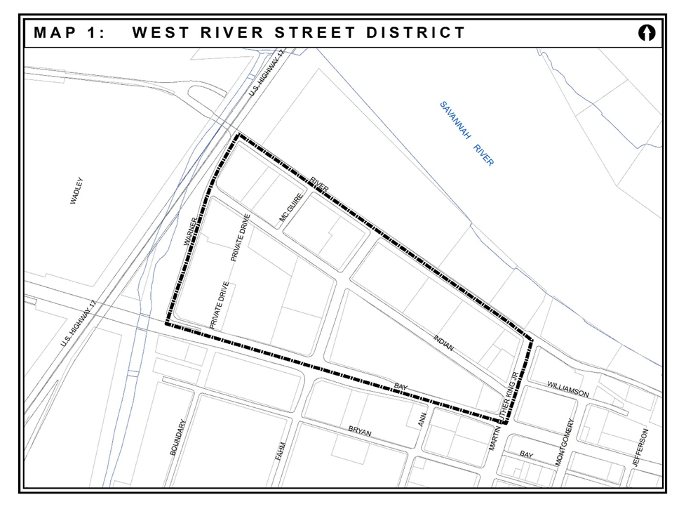
- Uses within the categories listed in Table 1: Permitted Parking Reduction, that are in the boundaries of the West River Street Area, shall be permitted to reduce the number of off-street parking spaces required in Sec. 8-3089 (Minimum space requirements for off-street parking).

Table 1: Permitted Parking Reduction
Use Categories  Sec. 8-3025 (b) B&I Use Schedule | Permitted Reduction
Lodging Facilities [1] | 50%
Retail Sales and Service | 50%
Community Facilities | 50%
Restaurants | 50%
Incidental Uses | 50%
Unclassified Retail Sales and Service | 50%
[1] Provided, however, that this reduction shall apply to transient guests only and that a minimum of one-half space per room be provided.

- Any use that is not within the use categories listed in Table 1 shall meet the requirements set forth in Sec. 8-3089 (Minimum space requirements for off-street parking).

- Any on-street parking spaces which abut a property line in the West River Street Area may be counted toward the required parking for a single use on such property.

(f) B-C and B-G districts. Within the boundaries of the Historic District, as described in Sec. 8-3030, but not to include the West River Street Area as described in (e) above, a minimum of one (1) off-street parking space per dwelling unit is required when there are no more than two bedrooms. For three (3) or more bedrooms, a minimum of 1.5 off-street parking spaces is required.

- HISTORIC DISTRICT

Sec. 8-3030(n)(16)e. Historic District; Design Standards; Large Scale Development; Height.

(iii) Multiple ground floor active uses permitted in the base zoning district (including but not limited to retail, office, lobby, restaurant) span the length of the façade on all street fronting elevations (not including lanes) and maintain individual primary exterior entrances. This option is not available for the upper-story residential use within the B-C and B-G districts. See Sec. 8-3025(b)(4)b.

SECTION 2: That the requirement of Section 8-3182(f)(2) of said Code and the law in such cases made and provided has been satisfied. That an opportunity for a public hearing was afforded anyone having an interest or property right which may have been affected by this zoning amendment, said notice being published in the Savannah Morning News, on the 21st day of May, 2017, a copy of said notice being attached hereto and made a part hereof.

SECTION 3: Upon the effective date of the ordinance all ordinances or parts of ordinances in conflict herewith are hereby repealed.

ADOPTED AND APPROVED: JULY 6, 2017

