MEMORANDUM

To: Mayor and Aldermen
From: Michael Brown, City Manager
Date: July 2, 2021
Subject: DeLesseps/Laroche Ave. Widening Project Agenda Item

On the July 8th Council Agenda, the Mayor and Aldermen will consider authorizing the City Manager to execute a contract for DeLesseps/Laroche Ave. Widening Project with APAC-Atlantic, Inc. in the amount of $6,910,645. This memo provides background regarding the pending road improvement project.

EXISTING CONDITIONS:
DeLesseps Avenue is a two-lane roadway classified as an Urban Collector and crosses Truman Parkway connecting Waters Avenue, an urban minor arterial, with Skidaway Road, an urban principal arterial.

No sidewalks or bicycle facilities are currently present within the project limits. However, sidewalks exist along LaRoche Avenue, connecting to this project just west of Skidaway Road. The traffic lanes vary in width, roadside drainage is sporadic, and there is no curb & gutter within the corridor except near the intersections on each end of the project and on the bridge approaches. Two schools, Savannah State University and Lee Roy Myers Middle School are located in the vicinity of this project.

Existing conditions east of Truman Parkway (no sidewalks, patched roadway, no curb/gutter)

Existing conditions west of Truman Parkway (no sidewalks, patched roadway, no curb/gutter)

NEIGHBORHOOD IMPACTS/NOTICE:
As a requirement of Georgia Department of Transportation’s (GDOT) Plan Development Process, public information open house meetings were held during the preliminary design phase. Additionally, the Traffic Engineering Office has been coordinating with the City of Savannah Community Outreach Coordinator for the Edgemere/Sackville Neighborhood Association since last summer by providing monthly updates.

Required right-of-way has already been acquired and certified by GDOT. Easements have been cleared of obstructions, including fences and vegetation.

PROPOSED IMPROVEMENTS:
The project would enhance DeLesseps/LaRoche from Waters Avenue to Skidaway Road (1.4 miles) by constructing pedestrian facilities and roadside drainage for the entire corridor and bicycle facilities for a portion of the corridor. Improvements will include the following:

- Two 11-foot travel lanes (overlaid, combining milling and leveling as needed to facilitate positive drainage) with curb & gutter.
- Five-foot sidewalks adjacent to the back of curb on both sides of the DeLesseps/LaRoche for the length of the project.
- Four-foot bike lanes east of Truman Parkway between travel lane and curb/gutter for both east and westbound travel, approximately 0.8 miles.
- Drainage improvements: including catch basins, drain inlets, and the elimination of drainage ditches for the entire length of the project.
- Improved pavement markings, including marked crosswalks at cross streets.
- The existing traffic signals will be modified to include pedestrian phases, signal heads, and push-button stations.
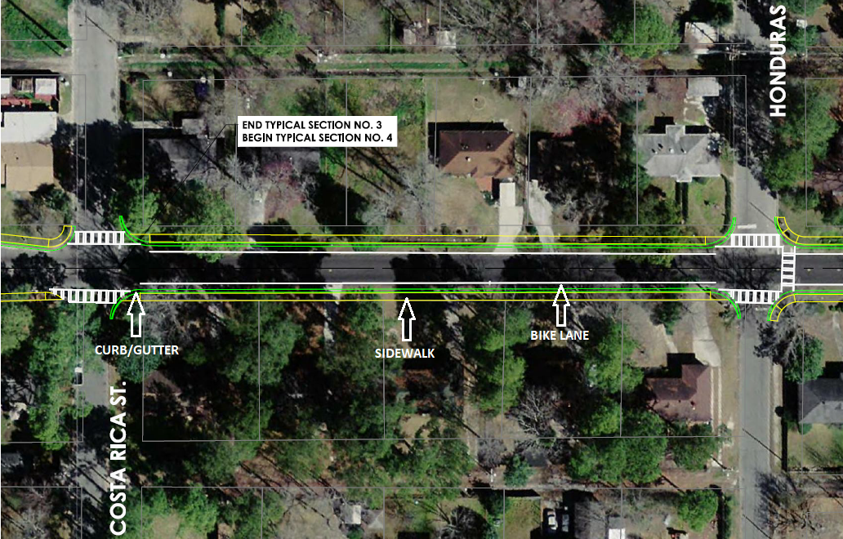

PROJECT FUNDING & COST:
This project was added to the Savannah MPO Transportation Improvement Program (TIP) using MPO-controlled federal funds in order to develop this project that will provide non-motorized transportation improvements on DeLesseps Avenue. The project was consequently added to the GDOT work program.

Bids for construction were initially received in January 2021. There was only one bidder and the bid exceeded the engineer’s construction estimate. The amount of the bid was $6,933,920. At GDOT’s recommendation, the City rebid the project. Bids for were received, and again, there was only one bidder. The amount of the bid was $6,910,645. GDOT recommended that the City move forward with the second bid.

Delays created by rebidding the project make awarding the contract time-sensitive in order to secure federal funding for construction.

