Proposed On-street Parking Restriction
Causton Bluff Road

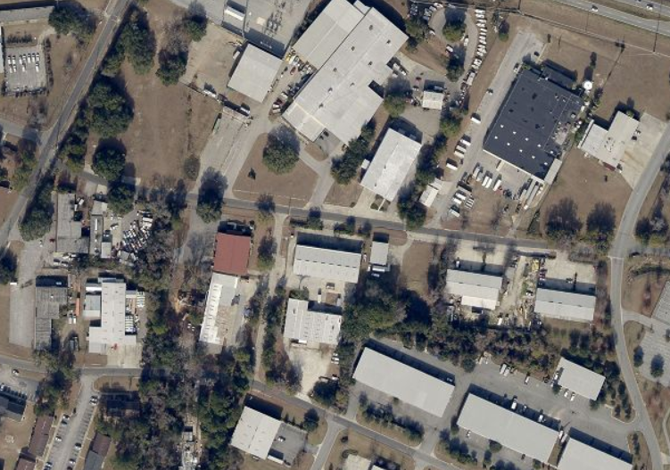
Riverview Dr.
Causton Bluff Rd. St. St.
Deptford St.
Proposed Parking Restriction
Gregory St.
Capitol St.

