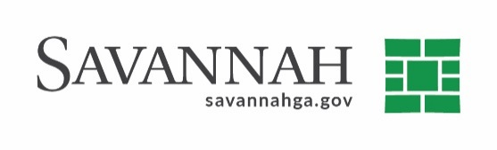
Funding Verification Form
Event #7197 | Title: Bryan Street Spall Repair
Amount
$ 28,433.41
Total Funding Amount:

Funding Source:

Budget Yr | Fund | Department | Account | Activity
2021 | 311-Capital Impr. Fund | 9207-Capital Impr. Projects | 52840-Other Costs | PB0631- Pkg Garage Repair

Notes
Fiscal Impact Statement: Capital Budget Amendments are required to complete this close-out due to unforeseen overruns in the project.

