**Current Site Location at 215 W. Broughton Street**

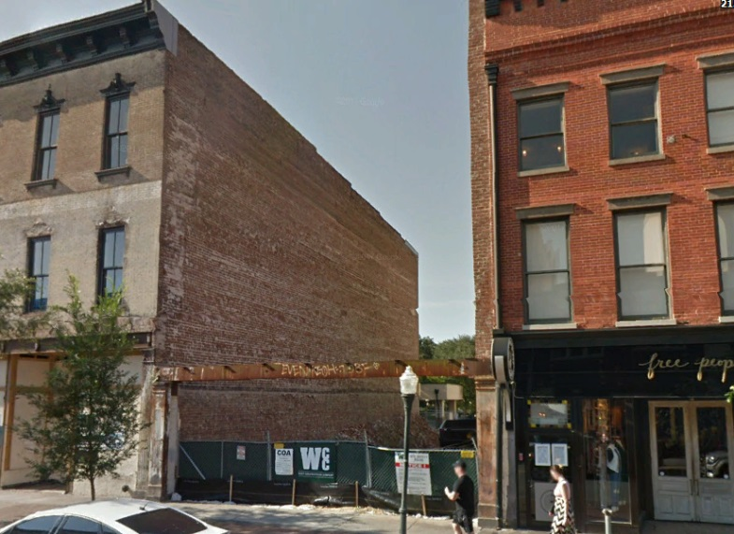

**Proposed Building Design**

