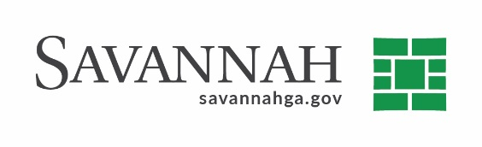
Purchasing Notes
Event #8726 | Title: Four Bar Screens | Cost: $53,030.00
Type of Procurement Sole Source | Annual Contract ☐  Annual Maintenance Agreement ☐ | One Time Purchase ☒
Contract Term (If Applicable)
N/A
S/DBE (If Applicable)

Matrix (If Applicable)
N/A
Notes
Recommend approval to procure four bar screens from WSG & Solutions (160 Commercial Dr. Montgomeryville, PA), Inc. in the amount of $53,030.00.

The stationary bar screens located that the DeRenne Stormwater Pumping Station are designed to remove floating debris from incoming stormwater that flows in the Casey Canal.

This is a sole source purchase because this vendor is the only proprietary supplier of these parts.

Delivery: As needed. Terms: Net 30 days. The vendor is:

S.S. WSG & Solutions, Inc. (160 Commercial Dr. Montgomeryville, PA) (D) $53,030.00

(D) Indicates non-local, non-DBE business. Recommend approval.

